TFEIP Guidance on the use of Earth Observations– Draft

1. Introduction
- What: Guidance on using earth observations for emission calculations and verification
- Why: Because its an emergent technique that will only become more important over time
- for whom: Inventory compilers that are not themselves experts in these techniques
- which gases (NOx, CH4, NH3, …)

2. Background on Earth Observations

2.1 Earth observations by satellite
- Basic principle and some numbers
- Geostationary and polar orbits
- Limb-viewing and nadir-viewing satellites
- Active and passive satellites

2.2 Concentration measurements of air pollutants
- In situ and satellite
- Principle of satellite observations with optical methods
- Principle of in situ with coverage, footprints + a box with existing networks

2.3. Overview of existing and planned satellites for Earth Observations
- Table with relevant satellites that are operational, launched or scheduled

3. Earth observations as a data source for emission inventories

3.1 Introduction

3.2 Earth observations as activity data
- Might be best to structure them by examples or use cases (a subsection each)
- Wildfire emissions (GFAS for example uses MODIS data)
- Spatial distribution of emissions with satellite land use data
- …

3.2. Data sources
- Existing commercial and non-commercial datasources
  - CLMS

4. Earth observations for emission verification

4.1 Introduction
How do we know that the emission numbers that we calculate with much effort and that form the basis of many policies are actually a faithful representation of reality? Ideally, one would want to verify them against independent emission data. However, truly independent emission data is hard to come by. Although there exist independent emission inventories, they usually rely on similar emission factor and activity data and therefore are only somewhat independent. One possibility for truly independent emission estimates of air pollutants is to measure the concentrations of these air pollutants in the atmosphere. This can be done by means of large towers, the so called in situ measurements, or by using satellites. In either case, the measured quantity is the concentration of a substance in the atmosphere (how much of a substance is in the atmosphere), while inventory compilers are interested in emissions (how much of a substance is added to the atmosphere). Therefore an additional step is required to derive emissions from these concentration measurements. There exist different approaches to solve this inverse problem, with the most prominent one being inverse modelling. Both the measurement infrastructure as well as the analysis techniques underwent great improvements in recent years and will continue to do so going forward. These analyses will typically not be carried out by inventory compilers themselves as they require very specialized expertise, but these methods can still be a valuable data source to support inventory compilers. They can not only be used to verify the correctness of the estimated emissions, but they can also provide emission estimates in regions that lack the infrastructure or data to calculate national emissions.

4.2 Background on Inverse Modelling

Inverse modelling is used to solve the inverse problem of finding the right emissions that fit the measured concentrations. The basic principle is shown in figure X. It starts with the a priori or prior emissions, typically from an emission inventory. Then, a chemical transport model is used to calculate the expected atmospheric concentrations based on these emissions. Besides the prior emissions additional inputs to the transport model are meteorological conditions and the boundary condition, i.e. the atmospheric concentrations at the edge of the domain. The model then returns the concentrations that would be expected for these prior emissions. Additionally, one has a set of measured concentrations or observations. Finally, an optimizing algorithm compares the expected and the measured concentrations and can tweak the prior emissions to minimize the mismatch between the two, which finally returns the a posteriori or posterior emissions. These posterior emissions present the main output of the Inverse Modelling and can be compared to inventory emissions.
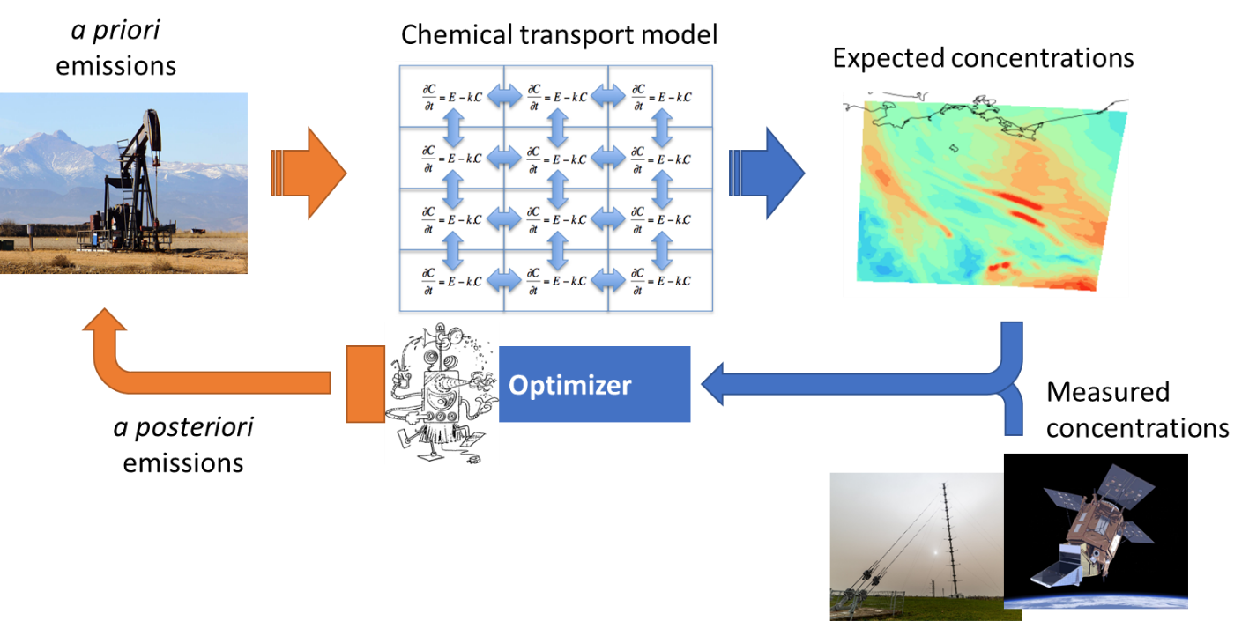
Fig. X
- Lifetime of gas in atmosphere
Each of these components going into Inverse Modelling have an impact on the resulting posterior emissions and will be briefly described in the following section.
Prior emissions The prior emissions are usually a gridded emission inventory. This can be the national inventory but most commonly international emission inventories like EDGAR or CAMS-Reg-Ant are used, because they provide consistent emissions across country boarders. These emissions do not only need to be spatially gridded, but also have a temporal profile, i.e. instead of yearly emissions the models often use daily or hourly emissions as input. Additionally, for the statistical model the uncertainties of these emissions are needed, which are often not well characterized, as also the additional uncertainty of the spatial distribution needs to be included.
Since the posterior emissions are basically a statistical compromise between the prior emissions and the observations, they are strongly influenced by the prior emissions. Therefore, ideally, the prior emissions should be consistent with the inventory. There are some algorithms, like the DECSO algorithm, that does not require the input of prior emissions, as it uses the emissions of the previous day as an input to the next day.
- Chemical transport model
- Meteorology
- Boundary conditions
- Optimizer

4.3 Other methods to derive emissions from atmospheric observations
- Plume fitting
- Divergence method

4.4 Data sources
- Existing non-commercial data sources
  - CAMS
  - TEMIS
  - Projects
  - ICOS
  - World emissions
- commercial data sources
  - GHGSat
- Establishing a national verification regime with examples
- academic cooperations
- technical aspects
  - Working with netcdf
  - Tools to analyze data Fluxy, UBA-Tool

4.5 Reconciliation with inventory emissions

- Comparison of
  - national total,
  - trends,
  - spatial and temporal patterns,
  - sectors,
  - point sources
- with examples, e.g. Germany, Netherlands,

4.6 Further resources
- Links to other guidance documents (
WMO IG3IS guideline
Output of H2020 projects,
AVENGERS and IG3IS webinars
links to projects

