the design of the experiment set up for deriving the accompanying Aircraft type/ emissions Excel table

EUROCONTROL method for estimating aviation fuel burn and emissions
---
EMEP/EEA air pollutant emission inventory guidebook annex 1 2023

DOCUMENT IDENTIFIER: N/A

Edition Number : 2.1
Edition Date : 2023/03/02
Status : Released Issue
Intended for : General Public
Category : EUROCONTROL Specification

DOCUMENT CHARACTERISTICS
TITLE
EUROCONTROL
Method for estimating aviation fuel burn and emissions
in the framework of
the annex1 of the EMEP/EEA air pollutant emission inventory guidebook 2022

Publications Reference: |  |  | N/A
Document Identifier |  | Edition Number: | 2.0
N/A |  | Edition Date: | 2023/01/24
Abstract
This document outlines the methodology used for calculating the raw data utilized in the "1.A.3.a Aviation Annex 1 2023.zip," which accompanies the EMEP/EEA Air Pollutant Emission Inventory Guidebook 2023. The raw data represents the estimated mass of fuel burnt and the associated masses of emissions that could be produced by a representative set of flights (aircraft types/engines) flying at their most commonly used cruise altitude or flight level over a predefined set of distances referred to as "reference stage lengths.
Contact Person(s) | Email |  | Unit
Laurent BOX | EUROCONTROL Fuel and Emissions Inventory  fuelandemissionsinventory@eurocontrol.int |  | EGSD/ASU

STATUS, AUDIENCE AND ACCESSIBILITY
Status |  | Intended for |  | Accessible via
Working Draft |  | General Public |  | Intranet
Draft |  | EUROCONTROL |  | Extranet
Proposed Issue |  | Restricted |  | Internet (www.eurocontrol.int)
Released Issue

DOCUMENT APPROVAL
The following table identifies all management authorities who have successively approved the present issue of this document.
AUTHORITY | NAME AND SIGNATURE | DATE
Project leader | Robin DERANSY

DOCUMENT CHANGE RECORD
The following table records the complete history of the successive editions of the present document.
EDITION  NUMBER | EDITION  DATE | REASON FOR CHANGE | PAGES AFFECTED
0.1 | 2016/06/04 | New document | All
1.0 | 2016/06/29 | Revised and upgraded to Release issue | All
2.0 | 2023/01/24 | Revised title and updated to release issue | All

CONTENTS
DOCUMENT CHARACTERISTICS 2
DOCUMENT APPROVAL 3
DOCUMENT CHANGE RECORD 4
CONTENTS 5
LIST OF FIGURES 7
LIST OF TABLES 8
1. Introduction 9
1.1 Purpose of the document 9
1.2 Glossary 9
1.3 References 10
2. Description of the calculation method 11
2.1 The annex 11
2.2 Calculation method high level requirements 12
2.3 The main steps of the method 12
2.4 Annex setup 14
2.4.1 Distance bands 14
2.4.2 LTO time in mode 14
2.5 Data sample 15
2.5.1 Selecting the aircraft types to model 15
2.5.2 Reference flight database 15
Aircraft types selection 15
2.5.3 15
2.5.4 Aircraft type characteristics 15
2.5.5 Determining the maximum operated/operable distance Band 16
2.5.6 Determining cruise flight levels 17
2.6 Determination of the CCD trajectory 17
2.6.1 Aircraft mapping 17
2.6.2 Airport setup 18
2.6.3 IMPACT performance model 19
2.6.4 Use of ANP data to calculate trajectories below 6000ft/10000ft 19
2.6.5 BADA Total Energy Model (TEM) implementation above 6000ft/10000ft 19
2.6.6 Optimal cruise management 20
2.6.7 Output of IMPACT 20
2.7 Determination of the mass of fuel burnt and the masses of emissions with AEM 20
2.7.1 AEM Aircraft mapping 20
2.7.2 Fuel burn calculations 21
2.7.2.1 LTO segments 21
2.7.2.2 CCD segments 21
2.7.3 Emissions calculations 22
2.7.3.1 LTO segments 22
2.7.3.2 CCD segments 22
2.7.4 CCD emissions adjustment 23

LIST OF FIGURES
Figure 1: EMEP/EEA Annex 1 architecture 12
Figure 2: Calculation method process 13
Figure 3: CCD Distance band 14
Figure 4: A318 Cruise levels 17
Figure 5: CCD performance model 19
Figure 6: AEM fuel burn calculation 21
Figure 7: AEM emissions calculations 22
Figure 8: Distance band offsetting 23
Figure 8: Reference stage length versus actual aircraft stage length 24

LIST OF TABLES
Table 1: Distance bands 14
Table 2: LTO time in modes 15
Table 3: Example of aircraft type details from the EUROCONTROL Historical Flight Database 16
Table 4: Example of spread of movements by variant 16
Table 5: Example of IMPACT Aircraft mapping 17
Table 6: List of IMPACT airports reference locations 18
Table 7: Example of AEM Aircraft engine mapping 21

Introduction

Purpose of the document
This document describes the method followed for the calculation of the raw data that are used in the “1.A.3.a Aviation annex 1 20223.zip” accompanying the EMEP/EEA air pollutant emission inventory guidebook 2023 These raw data correspond to the estimation of mass of fuel burnt and the associated masses of emissions that could be produced by a representative set of flights (aircraft types/engines), flying according to their most often used cruise altitude (or cruise flight level) a set of pre-defined distances called “reference stage lengths”.

Glossary
Acronym | Definition
AEM | EUROCONTROL Advanced Emissions Model  https://www.eurocontrol.int/services/advanced-emission-model-aem
ANP | Aircraft Noise Performance database  http://www.aircraftnoisemodel.org/
BADA | Base of Aircraft DAta. The EUROCONTROL Aircraft Performance Model  http://www.eurocontrol.int/services/bada
CAEP | Committee on Aviation Environmental Protection  http://www.icao.int/environmental-protection/pages/CAEP.aspx
CCD | Cruise Climb and Descent (flight phases)
ECAC | European Civil Aviation Conference  https://www.ecac-ceac.org
ICAO | International Civil Aviation Organisation  http://www.icao.int/
IFR | Instrument Flight Rules  http://www.skybrary.aero/index.php/IFR
IMPACT | Integrated aircraft noise and emissions modelling platform of EUROCONTROL  https://www.eurocontrol.int/platform/integrated-aircraft-noise-and-emissions-modelling-platform
ISA | International Standard Atmosphere  ISO 2533:1975/Add 2: 1997  http://www.skybrary.aero/index.php/International_Standard_Atmosphere
LTO | Landing and Take Off (flight phases)
QNH | Regional or airfield pressure setting
FEIS | Aviation fuel use and emission inventory system
TMA | Terminal Manoeuvring Area
EHFdb | EUROCONTROL Historical Flights Database. EUROCONTROL database that stores aircraft movements from 2005 to 2022.  Worldwide fleet database used to provide ATM enriched airframe specific data for use by external stakeholders and EUROCONTROL business units.”  http://www.eurocontrol.int/services/prisme-fleet
EUROCONTROL | EUROCONTROL, the European Organisation for the Safety of Air Navigation, is an intergovernmental organisation with 41 Member States, committed to building, together with its partners, a Single European Sky that will deliver the air traffic management performance required for the twenty-first century and beyond.  http://www.eurocontrol.int/
IMPACT | EUROCONTROL online tool dedicated to multi-airport environmental impact assessments for noise, gaseous and particulate emissions, and local air quality.  https://www.eurocontrol.int/services/impact

References
- EEA – EMEP/EEA air pollutant emission inventory guidebook (https://www.eea.europa.eu/themes/air/air-pollution-sources-1/emep-eea-air-pollutant-emission-inventory-guidebook)
ICAO - Annex 16 to the Convention on International Civil Aviation — Environmental Protection Volume II — Aircraft Engine Emissions
- ICAO – Doc 9889 – Airport Air Quality – Second edition
- ICAO – Doc 9646 – Engine Exhaust Emissions Data Bank
- ICAO – Doc 8643 – Aircraft Type Designators
- ICAO – Doc 9911 – Recommended Method for Computing Noise Contours around Airports
- ECAC – Doc 29 – 3rd edition – Volume 1 & 2 - Report on Standard Method of Computing Noise Contours Around Civil Airports
- SAE Air 5715 – Procedure for the Calculation of Aircraft Emissions
- Global Civil Aviation Black Carbon Emissions. ACS Publications (2016) - Marc E. J. Stettler, Adam M. Boies, Andreas Petzold, and Steven R. H. Barrett - https://doi.org/10.1021/es401356v
- EU-EUROCONTROL Aviation fuel and emissions inventory system - https://www.eurocontrol.int/database/aviation-fuel-use-and-emission-inventory-system
- ICAO CAEP Models and Databases - https://www.icao.int/environmental-protection/pages/modelling-and-databases.aspx

Description of the calculation method

The annex
The “1.A.3.a Aviation annex 1 2023” is a standalone model that accompanies the EMEP/EEA air pollutant emission inventory guidebook [1]. The objective of this annex is to enable a user to determine the fuel burn and emissions amount of a given aircraft type by flown distance, in a simple approach, to enable Tier 2 calculations:
- The estimation of the aircraft fuel burn and engine emissions, for the Climb Cruise and Descent (CCD) and the Landing and Take Off (LTO) phases of flight, for a set of representative aircraft types, distance band and for a set of representative Landing and Take Off times,
- Where applicable, for each aircraft the following estimations
- The section type (CCD or LTO),
- The distance band for which the calculation is done,
- The most representative cruise level flow for this distance band,
- The flight duration in “hh:mm:ss” time format,
- The mass of Fuel burn in kg,
- The mass of emitted CO₂ in kg,
- The mass of emitted NO_{X} in kg,
- The mass of emitted SO_{X} in kg,
- The mass of emitted H₂O in kg,
- The mass of emitted CO in kg,
- The mass of emitted HC in kg,
- The mass of emitted PM non-volatile in kg,
- The mass of emitted PM volatile (organic volatile and sulphuric volatile) in kg,
- The mass of emitted PM TOTAL in kg,
- A simple identification of the aircraft type by its ICAO code, among the most representative aircraft flying in the European area since 2005,
- A set of pre-defined distance bands that corresponds to the CCD phases of flight of the usual hauls, corresponding to elevations above or equal to 3000ft,
- A navigation of each aircraft according to the most representative cruise altitude by distance band,
- A distance input function to enable the user to calculate the fuel and emissions for a user-defined distance band, by interpolation,
- A simple definition of the navigation in the LTO phases (below 3000ft) by using either the ICAO default time in modes or the average time in modes of the busiest airports (Taxi in and out, take off, climb out, approach and landing),
- A quick availability of the results with tables and graphs
The Aviation Annex1 integrates these requirements with an architecture that includes a frame that provides the user inputs and results displays, and a dedicated database that contains the pre-calculated fuel and emissions results by aircraft type, distance and LTO times (c.f. Figure 1)
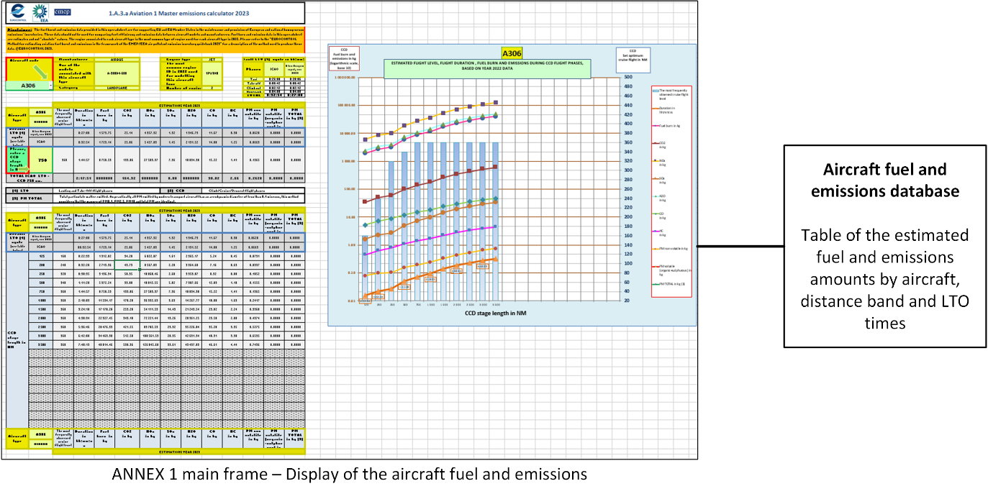
Figure 1: EMEP/EEA Annex 1 architecture

Calculation method high level requirements
The Annex 1 fuel burn and emissions database contents must comply with Annex1 requirements, the current EEA Fuel and Emissions Inventories System and the performance tools concepts and requirements:
- The Fuel and Emissions calculations modelling tool is the same as that used in the EEA Fuel and Emissions Inventories system [10].
- Each trajectory is divided into two parts: the Continuous Climb Departure (CCD) phase (above 3000ft) and the Landing and Take-Off (LTO) section (below 3000ft).
- The flight performances of the CCD section are calculated using the state-of-the-art Total Energy Model approach along a standard performance profile.
- The LTO flight phases are modelled using the time in mode approach, which calculates fuel burn and emissions based on engine emissions indices and constant durations by power setting, in accordance with the ICAO LTO certification cycle [2]. The selected time in mode durations include the ICAO default times in mode, as well as the average taxi in and taxi out times of the busiest airports in Europe.
- The atmospheric conditions along the trajectories are based on the International Civil Aviation Organization (ICAO) International Standard Atmosphere (ISA).
- The altitude of the departure and arrival airports (QNH) is set to 0 ft.

The main steps of the method
This document describes the different steps of the method to generate the contents of the Annex 1 database:
- Identification of the distance bands and Landing and Take Off times in mode
- Determination of the flights data sample. This includes:
  - The identification of the aircraft types to be modelled from the EUROCONTROL Historical Flights database, with their ICAO code
  - The identification of the engine of the selected aircraft types,
  - The identification of the maximum stage length that this aircraft type usually fly.
  - The identification of the most usual cruise levels flown by these aircraft for the listed distance bands
- Generation of the CCD trajectories for each aircraft type:
  - Aircraft mapping of the selected aircraft types with the aircraft performance model reference information models
  - Calculation of the trajectory from the brake release at take-off to the end of the runway landing deceleration landing for each distance band for the identified cruise level and reduction of the trajectory to the CCD limits (=>3000ft)
- Estimation of the Fuel burn and emissions masses for each aircraft type:
  - Calculation of the fuel burn and emissions for each distance band for the CCD Phases of flight.
  - Calculation of the fuel burn and emissions for the LTO section, for the identified LTO times in mode.
This method relies on the use of two main EUROCONTROL environmental impact assessment tools as shown in the Figure 2:
- The IMPACT modelling platform, and
- The Advanced Emission Modelling (AEM) model.
These tools have been recognised by the ICAO CAEP Working groups. They are compliant with the recommended practises as published by ICAO (see References [2], [3] and [11]).
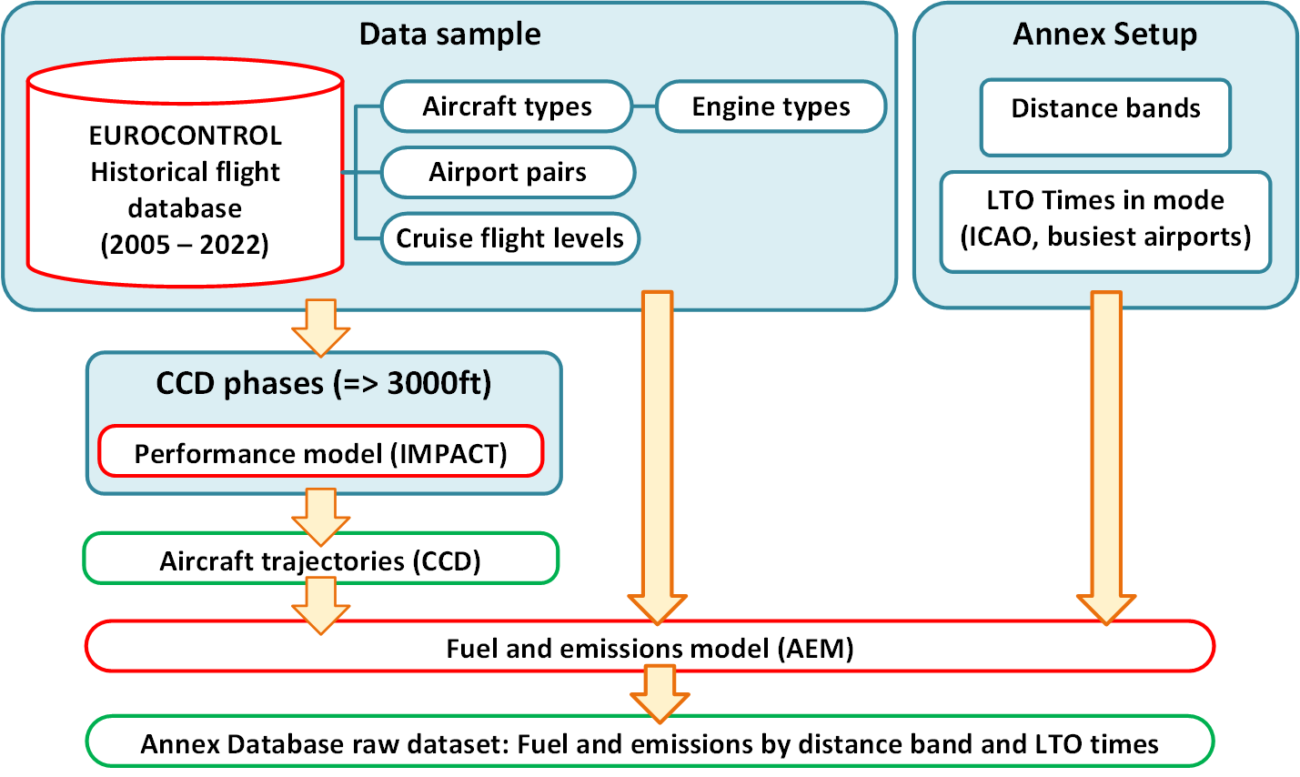
Figure 2: Calculation method process

Annex setup

Distance bands
The distance band (or Stage Length) is the great circle distance to be flown between the end of the ICAO LTO departure phase and the beginning of the ICAO LTO arrival phase, which corresponds to the trajectory flown with an altitude QNH greater or equal to 3000ft in ISA conditions (c.f. Figure 3)
Figure 3: CCD Distance band
The current Annex 1 proposes the distance band values:
Nm | Km
125 | 231.5
200 | 370.4
250 | 463
500 | 926
750 | 1389
1000 | 1852
1500 | 2778
2000 | 3704
2500 | 4630
3000 | 5556
3500 | 6482
4000 | 7408
4500 | 8334
5000 | 9260
5500 | 10186
6000 | 11112
6500 | 12038
7000 | 12964
7500 | 13890
8000 | 14816
8500 | 15742
9000 | 16668
9500 | 17594
10000 | 18520
Table 1: Distance bands

LTO time in mode
The LTO time in modes are the duration of the aircraft navigation along each LTO phases of flight according to the ICAO LTO certification cycle.

LTO phases | Time in mode |  | Engine power setting  (% of max thrust)
 | ICAO default | A busy European airport, year 2022
Taxi | 00:26:00 | 00:20:50 | 7%
Take off | 00:00:42 | 00:00:42 | 100%
Climb out | 00:02:12 | 00:02:12 | 85%
Approach | 00:04:00 | 00:04:00 | 30%
TOTAL | 00:32:54 | 00:27:44 | 30%
Table 2: LTO time in modes

Data sample

Selecting the aircraft types to model
The selection of the aircraft type involves identifying the characteristics of each available aircraft ICAO code in the annex. This step must provide the necessary aircraft parameters to enable the calculation of performance, fuel burn, and emissions, as well as the corresponding distance bands and cruise levels to be modelled.

Reference flight database
The EUROCONTROL Historical Flight database (EHFdb) stores worldwide IFR air traffic movements Each movement includes:
- A date and time,
- The aircraft type that is defined by:
- Its manufacturer, serie and model descriptors,
- Its engine type,
- The ICAO Code.
- The departure and arrival airports and the great circle distance between them,
- The cruise level.
To ease the use of this detailed information, the process aggregates these movements by year, aircraft type, great circle distance rounded to 10 Nm and cruise altitudes rounded to 1000 for ECAC departures and arrivals. This step allows a ranking by number of movements and ease the distance and cruise altitude determination.

Aircraft types selection
To focus the Annex 1 on the most representative aircraft types, it has been decided:
- To select only landplanes with JET, TURBOPROP/TURBOSHAFT and PISTON engine types,
- To select, from the EHFdb, the aircraft types with more than 1000 departures and/or arrivals the ECAC area,
- To use the feedback of the verification of the trajectory calculations to determine any correction to this list.

Aircraft type characteristics
In the EHFdb, each aircraft type selected represents a certain range of variants using different engine types with similar performances.
Example: ICAO Code A318
The following table shows the different airframe and engine variants that are referenced by the same ICAO code of the aircraft type:
ICAO CODE | AIRFRAME |  |  | ENGINE
 | MANUFACTURER | MODEL | SERIE | NAME
A318 | AIRBUS INDUSTRIE | A318 | A318 121 | PW6122
A318 | AIRBUS INDUSTRIE | A318 | A318 111 ELITE | CFM56-5B8/P
A318 | AIRBUS INDUSTRIE | A318 | A318 112 ELITE | CFM56-5B8/P
A318 | AIRBUS INDUSTRIE | A318 | A318 112 | CFM56-5B8/P
A318 | AIRBUS INDUSTRIE | A318 | A318 111 | CFM56-5B8/P
A318 | AIRBUS INDUSTRIE | A318 | A318 122 | PW6124A
Table 3: Example of aircraft type details from the EUROCONTROL Historical Flight Database
The airframe and engine combinations are key inputs to correctly map the selected aircraft types with the performance, fuel and emissions models.
For each ICAO code, the number of movements by year allows a ranking that identifies the most representative airframe and engine couple. Therefore, in the Annex 1, a selected ICAO code corresponds to the most representative set of performances, fuel burn and emissions characteristics for this aircraft type according to the EHFdb. For each ICAO code, and where Y is the year of the annex release, the process establishes the “most representative” setup with, by priority:
- The airframe and engine couple with the maximum number of movements in year Y-1,
- If no movements are recorded in Y-1, then the airframe and engine couple with the maximum number of movements from Y-2 backwards to 2005
Example: ICAO Code A318
For the A318, the reference models do not distinguish between the different available series: they are simplified as “A318 100”. The Table 4 shows the distribution of the number of movements of the A318 in 2022. The most representative airframe-engine couple determines the characteristics of the A318 ICAO code as the “A318 100” and the CFM56-5B8/P.
ICAO | AIRFRAME | ENGINE | Number of operations in 2022
A318 | A318 100 | UNKNOWN | 0.001%
A318 | A318 100 | PW6124A | 0.008%
A318 | A318 100 | CFM56-5B8/P | 99.885%
A318 | A318 100 | PW6122 | 0.105%
Table 4: Example of spread of movements by variant

Determining the maximum operated/operable distance Band
Due to economic reasons or their performance limitations, some of the selected aircraft types may not be operated or cannot be operated on certain reference stage lengths listed above.
The maximum reference stage that can be operated by a specific aircraft type is determined by querying the EHFdb or by using the maximum operation range declared by the manufacturer.
Therefore, for each aircraft type, the fuel burn and emissions calculations are restricted to distance bands listed as equal to or lower than the maximum operated distance.

Example: ICAO Code A318
- The maximum declared range is 4200 Nm according to the manufacturer for the Corporate Jets versions, and 3100 Nm with typical payload.
- The maximum operated range is 4100 Nm according to the EHFdb.
To comply with the calculation of the performances the maximum range is set to 3500 Nm. Therefore, for the A318, the Annex 1 provides fuel burn and emissions results for the distance bands lower or equal to 3500 Nm

Determining cruise flight levels
For each selected aircraft type and distance band, the EHFdb provided the most representative cruise levels, with, by priority and having “Y” as the report year:
- The cruise level that was mostly flown in the Y-1 year,
- The cruise level that was flown in average for the period 2005 to Y-2,
- The closest cruise level that can be processed by the performance model
Example: ICAO Code A318
The result of the assessment of the operated flights provides the following cruise levels for each distance band
Distance band (Nm) | Cruise altitude in FL (x100 ft)
125 | 180
200 | 240
250 | 300
500 | 380
750 | 380
1000 | 380
1500 | 380
2000 | 380
2500 | 380
3000 | 380
3500 | 380
Figure 4: Example of cruise levels by distance band

Determination of the CCD trajectory
The EUROCONTROL IMPACT trajectory calculator calculates the aircraft trajectory implying a design that implies on both the ANP for the take-off, initial climb, final descent and landing phases, and the BADA performance data for the en-route phases. The performance calculation method (c.f. Figure 5) is further described below.

Aircraft mapping
The initial phase of the modelling of the trajectories consists in the definition of the IMPACT model aircraft that corresponds to the defined Aircraft ICAO codes. This step corresponds to the identification of the corresponding ANP type and the BADA types. Unfortunately, the ANP database and the BADA databases (Families 3 and 4) do not provide the same list of reference models. To enable the modelling of a maximum number of aircraft, and to help proxy aircraft setting, the main drivers of this mapping exercise are then:
- The existence of the BADA model that has the performances of the ICAO code
- The respect of the Maximum Take Off Weight: the ANP model MTOW must not exceed the BADA model MTOW where possible
Example: ICAO Code A318
In the release 2023 of the annex, with ANP 2.3 and BADA 4.2 the resulting mapping of the A318 is:

ICAO CODE | ANP_TYPE | BADA4_TYPE
A318 | A319-131 | A318-112
Table 5: Example of IMPACT Aircraft mapping

Airport setup
To generate the flight trajectories for the selected distance bands, it is required to define a set of departure and arrival airports with ad-hoc coordinates. To ease the processing of the trajectories, IMPACT is setup to navigate the aircraft in the EAST direction (heading 90°) at a latitude of 0°. Therefore, the airports definition consists in:
- A unique departure airport with latitude and longitude equal to 0°
- A set of airports corresponding to each distance band for which the latitude is always 0° and for which the longitude is determined by the distance band value with a supplementary offset of 15 Nm to allow climbing and descending phases below 3000ft.
The provides the list of airports
Airport name (Distance band)  AIRPORT | Latitude (°dec.)  REF_POINT_LAT | Longitude (° dec.)  REF_POINT_LONG | Elevation (ft)  ELEVATION_FT
0 | 0 | 0 | 0
125 | 0 | 2.337683 | 0
200 | 0 | 3.585051 | 0
250 | 0 | 4.416898 | 0
500 | 0 | 8.576144 | 0
750 | 0 | 12.73892 | 0
1000 | 0 | 16.89911 | 0
1500 | 0 | 25.22563 | 0
2000 | 0 | 33.54775 | 0
2500 | 0 | 41.86652 | 0
3000 | 0 | 50.18899 | 0
3500 | 0 | 58.5072 | 0
4000 | 0 | 66.83414 | 0
4500 | 0 | 75.15941 | 0
5000 | 0 | 83.48727 | 0
5500 | 0 | 91.8095 | 0
6000 | 0 | 100.1374 | 0
6500 | 0 | 108.4698 | 0
7000 | 0 | 116.7889 | 0
7500 | 0 | 125.1053 | 0
8000 | 0 | 133.4125 | 0
8500 | 0 | 141.7289 | 0
9000 | 0 | 150.0473 | 0
Table 6: List of IMPACT airports reference locations

IMPACT performance model
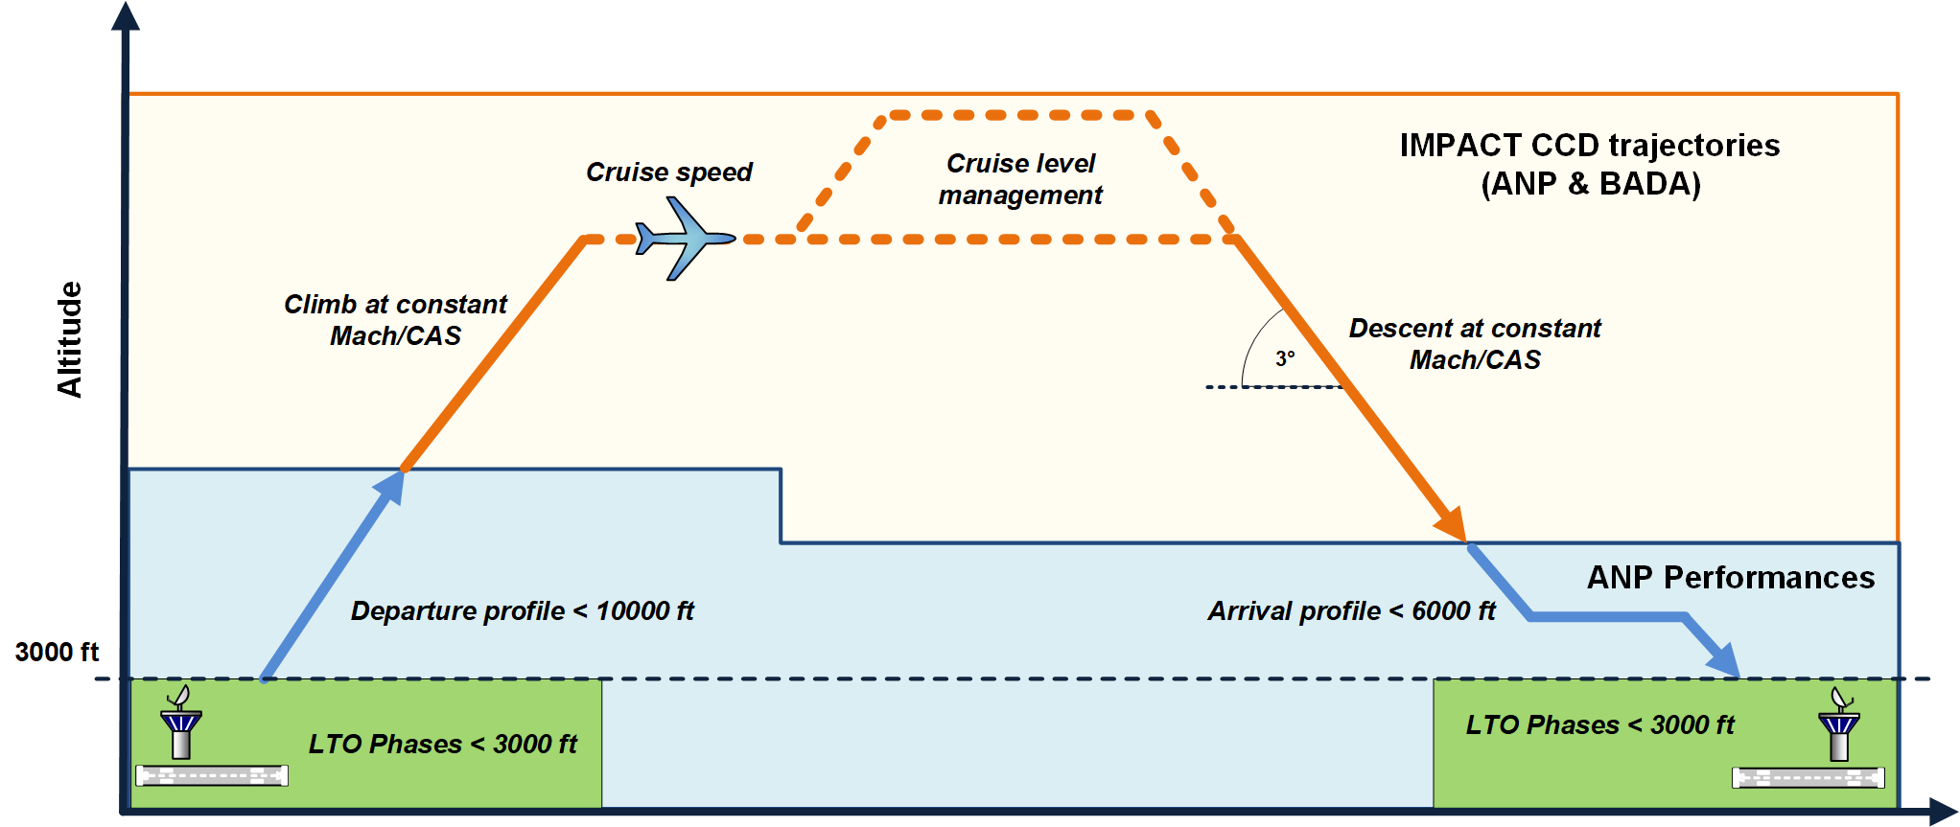
Figure 5: CCD performance model
The IMPACT model combines the use of two different models to calculate the trajectory between two airports, the ANP model for the departure sections below 10 000ft and arrival phases below 6000ft, including take-off and landing, and the BADA model for the remaining sections. In the context of the EEA Annex 1, the IMPACT calculation setup specifies that each model provides standard performance configuration to generate the trajectories. This implies the use of the DEFAULT ANP departure and arrival profiles, and the use of the nominal flight conditions with the BADA model.

Use of ANP data to calculate trajectories below 6000ft/10000ft
The IMPACT trajectory calculator uses the aircraft performance coefficients of the ANP database - in conjunction with the aircraft performance calculation method provided in ECAC Doc. 29 [6] and ICAO Doc 9911 [5] - to model aircraft trajectories within the TMA portion (more precisely below 10,000ft for departure and below 6000ft for arrivals).
IMPACT determines the aircraft mass at the take-off for the selected ANP aircraft model based on the trip length of the flight to model. The ANP data provides a set of default mass (fuel and payload), for a 65% load factor. These masses are provided by the manufacturers for a set of default distance bands. (c.f. ANP Default weights table)

BADA Total Energy Model (TEM) implementation above 6000ft/10000ft
BADA is an Aircraft Performance Model developed and maintained by EUROCONTROL, in cooperation with aircraft manufacturers and operating airlines. BADA is based on a kinetic approach to aircraft performance modelling, which enables aircraft trajectories and the associated fuel consumption to be accurately predicted. BADA includes both model specifications that provide the theoretical fundamentals to calculate aircraft performance parameters and the datasets containing aircraft-specific coefficients required to calculate their trajectories.
The BADA 3 family is today’s industry standard for aircraft performance modelling in the nominal part of the flight envelope and provides close to 100% coverage of aircraft types operating in the ECAC region.
The latest BADA 4 family provides increased levels of precision in aircraft performance parameters over the entire flight envelope and covers 70% of aircraft types operating in the ECAC region.
In the CCD portion (more precisely from 10,000ft in the climb phase, and down to 6,000ft in the descent phase), the trajectory calculator of IMPACT uses the BADA 4 data, in conjunction with a full implementation of the BADA Total Energy Model (TEM):
- After the ANP departure phase, the aircraft adapts its profile to fly the BADA nominal climbing procedure
- The nominal BADA climb procedure consists in a climb at max climb engine regime, with a constant CAS (or Mach after the “crossover” altitude)
- The nominal cruise consists in a cruise engine regime with a constant Mach (or CAS)
- The nominal descent consists in a descent at 3°, with a constant Mach (or CAS)
When BADA 4 performance data do not exist yet for a given aircraft type, its BADA 3 performance data is used instead. The calculation of the performances of each aircraft by IMPACT includes a fuel burn calculation and, therefore a loss of mass. Nevertheless, to comply with the Annex 1 requirements, the IMPACT fuel burn calculation is not used. The annex 1 uses the AEM model to calculate the fuel burn instead.

Optimal cruise management
The IMPACT model tries to find the trajectory that will allow each aircraft to reach the required cruise flight level entered as an input.
Depending on the aircraft type and the distance band, the pre-determined optimal cruise level might be too high to be reached directly at the end of the climb phase. In that case, a new intermediate and reachable optimal cruise level is calculated. The aircraft continues its cruise at this flight level until its weight enables it to reach the next best suitable flight level, with a maximum offset of 2000 ft. This process is repeated until the maximum “optimum” cruise level is reached.
The aim of this implementation is to model, as closely as possible, the “real life” operational management of aircraft in economic mode, when pilots require successive flight levels to Air Traffic Controllers.

Output of IMPACT
For each aircraft type and distance band, IMPACT provides the trajectory points with an altitude greater or equal to 3000ft, transformed in a list of segments that can be parsed by the AEM model.

Determination of the mass of fuel burnt and the masses of emissions with AEM
The EUROCONTROL AEM model calculates the fuel and emissions masses for the CCD and LTO phases of flight. It parses the trajectory segments from IMPACT, to calculate the fuel burn and emission masses depending on the phase of flight, either CCD or LTO (c.f. Figure 6 and Figure 7).

AEM Aircraft mapping
For each Aircraft ICAO Code, the calculation process requires to map it with the corresponding fuel and emissions reference models. This step reuses extensively the FEIS inventory aircraft mapping to determine:
- The fuel burn model (BADA)
- The number of engines
- The engine model in the reference databases
Example: ICAO Code A318
The Table 6 shows the AEM aircraft mapping of the A318 with the reference databases for the report of year 2022. In particular, the engine ID 7CM048 identifies the fuel and emissions indices of the CFM56-5B8/P in the ICAO EEDB databank version 28c.
ICAO CODE | BADA | ENGINE_ID
A318 | A318 | 7CM048
Table 7: Example of AEM Aircraft engine mapping

Fuel burn calculations
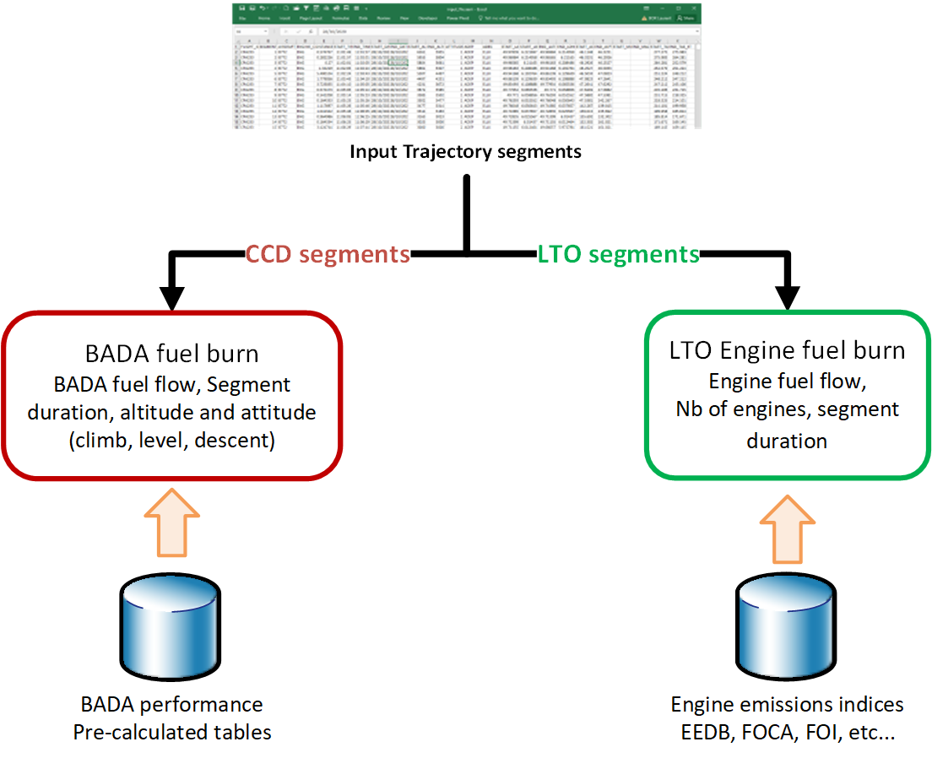
Figure 6: AEM fuel burn calculation

LTO segments
For LTO segments, AEM calculates the fuel burn by using the engine fuel flow indices as provided by the engine reference databases (ICAO EEDB, FOI, FOCA, etc…).
For an ICAO aircraft, and for each segment of the LTO section according to the ICAO LTO certification cycle:
$$With k ∈LTO segments,$$
$${Fuel burn}_{k}= Nb of engines ×{duration}_{k}{Segment duration}_{k} ×{Engine Fuel flow }_{k}$$

CCD segments
For CCD segments, AEM calculates the fuel burn by looking up the dedicated BADA tabulated pre-calculated fuel flow values of the mapped model: the determination of the fuel flow depends on the flight attitude in the segment (climb, cruise or descend), and the segment mean altitude.
The BADA tabulated performances are pre-calculated by the BADA team with the following setup:
- Nominal weight
- Constant weight all along the trajectory
- Climb at max climb engine thrust with a constant CAS (or Mach above the “crossover” altitude)
- Level with an adapted thrust (Drag equal to Thrust)
- Descent regime:
- For the main airliners: Idle thrust
- Other (some business, turbo, pistons): Low thrust for ROD recommended by the manufacturers:
  - Business: 2000 – 3000ft /min
  - General aviation: 500/1000ft/min

Emissions calculations
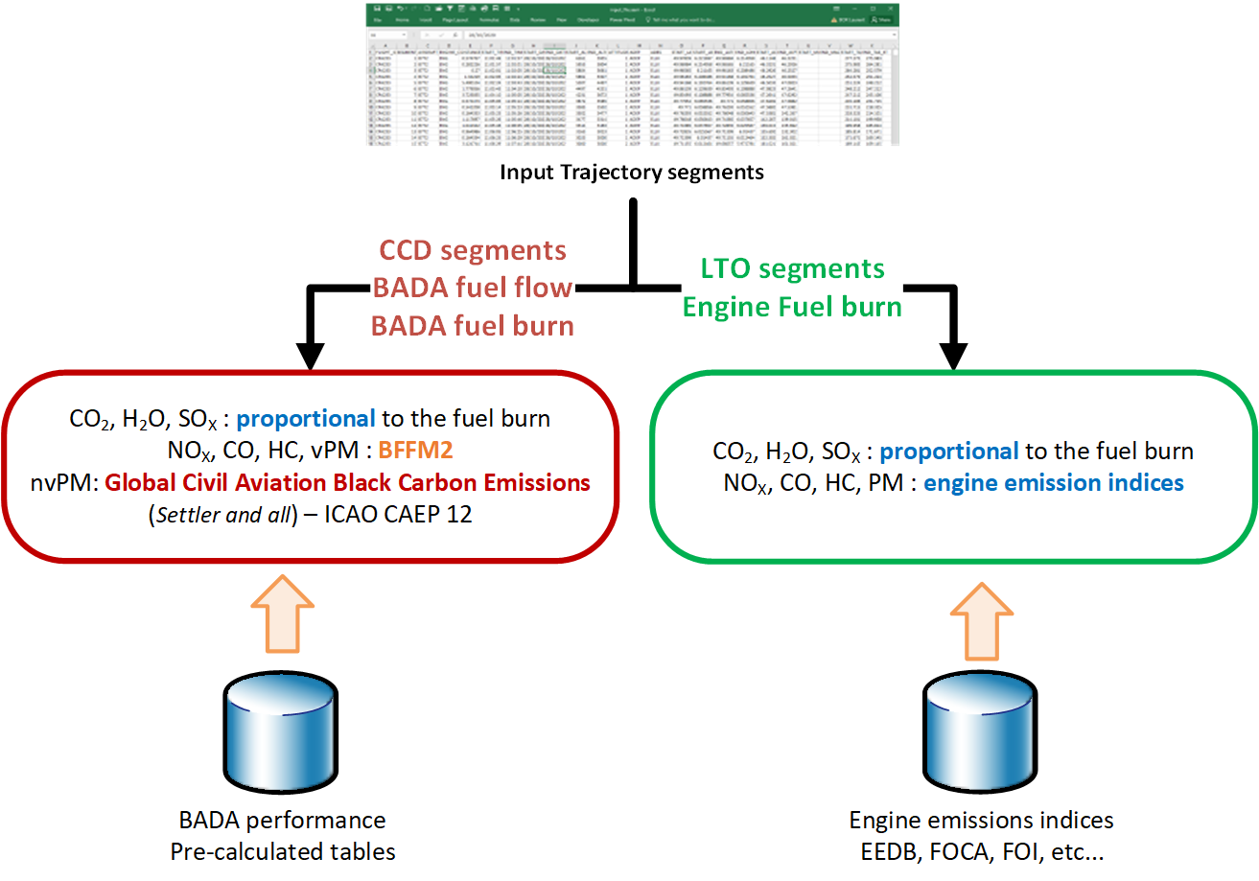
Figure 7: AEM emissions calculations

LTO segments
For LTO segments, AEM calculates the emitted masses of pollutants by using the calculated fuel burn and engine emissions indices as provided by the engine reference databases (ICAO EEDB, FOI, FOCA, etc…).
$$With k ∈LTO segments,$$
Then the mass of emitted pollutant P is:
$${Emissions}_{P, k}= {Fuel burn}_{k} ×{Emission index }_{P,k}$$
The Emission index of the concerned pollutant depends on the pollutant species:
- CO₂, SO_{X}, H₂0: constant (c.f. §2.7.3.3):,
- NO_{X}, HC, CO, Particulate Matters: Engine dependent, and provided by the engine emission indices tables (e.g. ICAO EEDB, FOCA, FOI, etc…)

CCD segments
The emissions calculations of the CCD segments depend on the type of pollutant:
- CO₂, SO_{X}, H₂0: the mass of pollutants is proportional to the fuel burn (c.f. §2.7.3.3):
$$With k ∈CCD segments,$$

$${Emissions}_{P,k}= {Fuel burn}_{k} ×{Emission index }_{P}$$
- NO_{X}, HC, CO, Particulate matters volatile (organic and sulfuric): AEM applies the Boeing fuel flow method version 2 [7], with:
- NO_{X}, HC, CO: The engine LTO engine emissions indices from the engine databases
- Particulate matters volatile (organic and sulfuric): the calculated engine emissions indices with the First Order Approximation method version 4
- The current engine emissions databases allow to calculate particulate matters volatile for jet engine only.
- Particulate matters non-volatile (nvPM): AEM applies the Global Civil Aviation Black Carbon Emissions (Settler and all) [8], with:
- Measured nvPM emissions indices from the ICAO engine emissions databases (Jets only)
- The calculated engine emissions indices with the First Order Approximation method version 4 when the engine emission database do not provide measure indices
- The current engine emissions databases allow to calculate particulate matters volatile for jet engine only.

Non-engine specific emissions indices
Assuming a JET-A fuel type, the emission indices (Ei) of the CO₂, SO_{X} and H₂0 pollutant species are constants:
$${Ei}_{{CO}_{2}}=3.15 Kg/{Fuel burn}_{kg}$$
$${Ei}_{H_{2}0}=1.237 Kg/{Fuel burn}_{kg}$$
$${Ei}_{{SO}_{x}}=0.00084 Kg/{Fuel burn}_{kg}$$
- The current engine emissions databases allow to calculate particulate matters volatile for jet engine only.

CCD emissions adjustment
The modelling of the performance of different aircraft types for the same distance band induces minor differences of “flown” distance. Indeed, all the aircraft do not cross the 3000ft altitude at the same location, compared to the departure and arrival airports. The consequence is that the distance of flight which concerns the CCD portion of the flight differs from one aircraft type to another (c.f. Figure 8) and de facto the basis for the fuel burn and emission calculation.
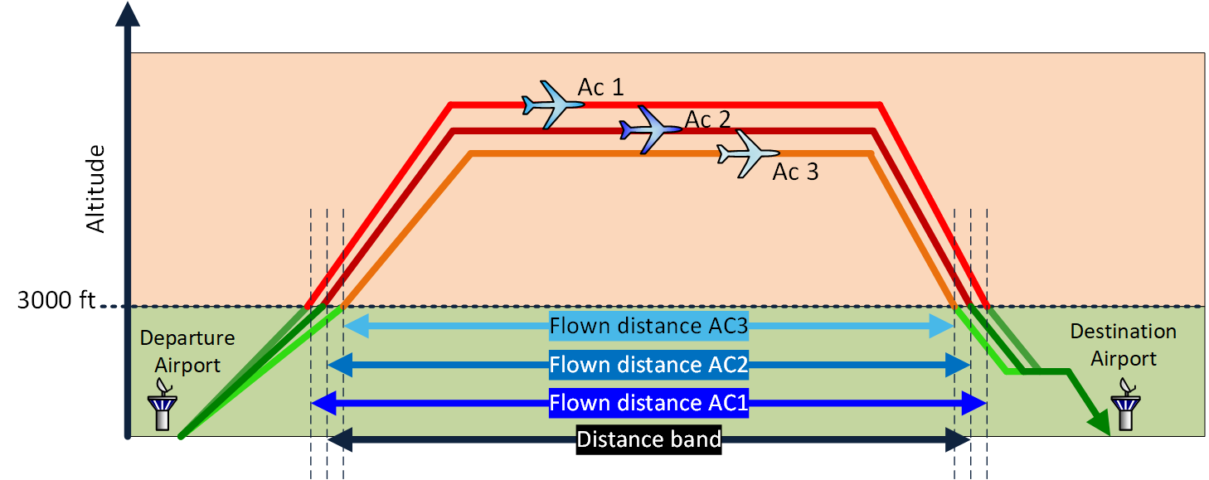
Figure 8: Distance band offsetting
This difference is greater for short distance bands than for longer ones (c.f. Figure 8) on average of the aircraft types, because of the range of very different performances of short-range flights (from single piston engines to heavy jets).
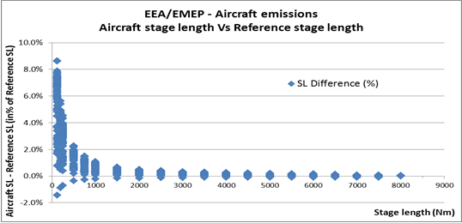
Figure 8: Reference stage length versus actual aircraft stage length

It can be noticed that this relative difference is less than 8.6% in the worst case (125Nm for BE60). For distance bands above 500 Nm, it is reduced below 2.5%. It is then assumed that the CCD fuel burn and emissions can be calculated by scaling the fuel burn and emissions values for each aircraft flown distance to the reference distance band.
We have then, for a given reference distance band:
$${Fuel burn}_{Distance band}=Fuel burn ×\frac{ CCD istance band}{CCD flown distance}$$
And, for a pollutant P:
$${Emissions}_{P, Distance band}={Emissions}_{P} ×\frac{ CCD istance band}{CCD flown distance}$$

--- End of document ---

