# TFEIP 2025 Practical Information

## Location

The meeting will take place **in Warsaw at** [**IOŚ-PIB**](https://ios.edu.pl/kontakt/) **office, Słowicza 32 St**.

The office is located:

* 3,5 km from the Warsaw main airport (Warsaw Chopin Airport) and 9 km from the Warsaw Central Railway Station;
* 20-25 minutes by public transport or about 7-10 minutes by taxi from the Chopin Airport;
* 35-40 minutes by public transport and 20-25 minutes by taxi from the Warsaw Central Railway Station.

The office, the airport and the railway station are all located within **ZONE 1** of public transport.

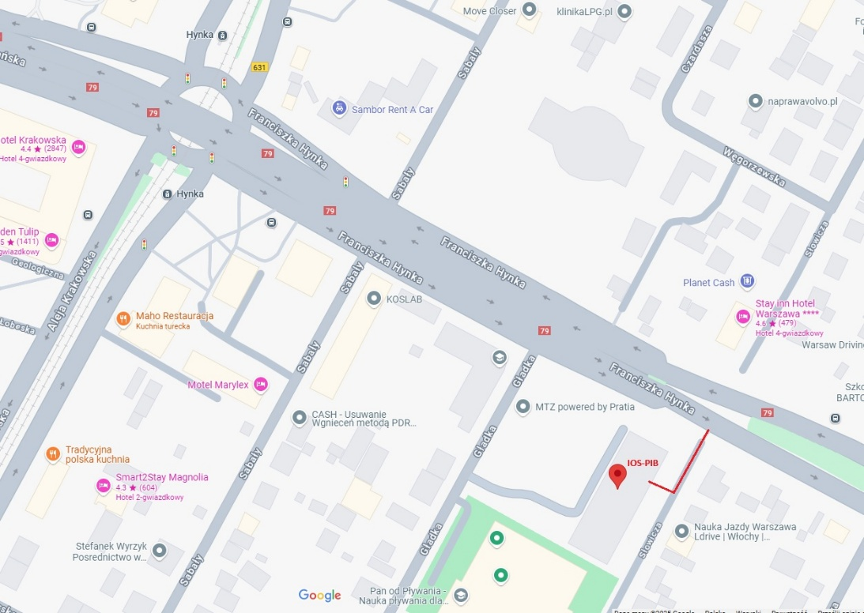

**Public Transport** tickets can be bought in ticket vending machines at tram/bus/metro stops or in newspaper shops using cash or a credit card. Tickets can be bought also via mobile apps - more information: <https://www.wtp.waw.pl/en/where-to-buy-a-ticket/ticket-by-mobile/> <https://warszawa19115.pl/-/ztm-ticket-purchase-in-mobile-applications>

There are several types of tickets: 20/75/90-minute tickets as well as 24‑hour or 72‑hour tickets which allow to travel with all types of public city means of transportation including buses, trams, metro and urban rapid rail (SKM).

**More information:** [**https://www.wtp.waw.pl/en/ticket-tariff/**](https://www.wtp.waw.pl/en/ticket-tariff/)

The exact travel instructions can be very easily obtained in “Google maps” after typing the appropriate locations. Public transport stops are located in front of the airport/central railway stations.

## Currency

The currency in Poland is the Polish zloty (1PLN ~ 0.24 EUR)

## Methods of payment

Credit cards are widely accepted in Poland.

## Hotels nearby IOŚ-PIB office (5-minute walk):

An information about the possibility of getting a reduced hotel price in one of the hotels will be provided at a later date.

## [Arche Hotel Geologiczna](http://www.archehotelgeologiczna.pl/), Geologiczna 4, 02-246 Warszawa

## [Golden Tulip](https://warsaw-airport.goldentulip.com/), Aleja Krakowska 235, 02-180 Warszawa

## [Arche Hotel Krakowska](http://www.archehotelkrakowska.pl/), Aleja Krakowska 237/U1, 02-180 Warszawa

## [Stay inn Hotel Warszawa](https://stayinnhotels.pl/warszawa), Słowicza 28, 02-170 Warszawa

## [Lord Hotel](https://hotellord.pl/), Aleja Krakowska 218, 02-219 Warszawa

## [Mercure Warszawa Airport](https://all.accor.com/lien_externe.svlt?goto=fiche_hotel&code_hotel=8999&merchantid=seo-maps-PL-8999&sourceid=aw-cen&utm_medium=seo+maps&utm_source=google+Maps&utm_campaign=seo+maps&y_source=1_MTUzNjIyMzEtNzE1LWxvY2F0aW9uLndlYnNpdGU%3D), Aleja Krakowska 266, 02-210 Warszawa

## Hotels in the city centre (30 minutes by means of public transportation from IOŚ-PIB):

## [Radisson Blu Sobieski](https://www.radissonhotels.com/en-us/hotels/radisson-blu-warsaw-sobieski?cid=a:se+b:gmb+c:emea+i:local+e:rdb+d:eerut+h:PLWAWSOB), plac Artura Zawiszy 1, 02-025 Warszawa

## [Golden Tulip Warsaw Centre](https://warsaw-centre.goldentulip.com/), Towarowa 2, 00-811 Warszawa

## [Campanile](https://varsovie.campanile.com/), Towarowa 2, 00-811 Warszawa

## [Polonia Palace Hotel](http://www.poloniapalace.com/), al. Jerozolimskie 45, 00-692 Warszawa

## [Novotel Warszawa Centrum](https://all.accor.com/lien_externe.svlt?goto=fiche_hotel&code_hotel=3383&merchantid=seo-maps-PL-3383&sourceid=aw-cen&utm_medium=seo+maps&utm_source=google+Maps&utm_campaign=seo+maps&y_source=1_MTUzNTg3NTctNzE1LWxvY2F0aW9uLndlYnNpdGU%3D), Marszałkowska 94/98, 00-510 Warszawa