Category |  | Title
NFR: | 1.A.3.a, 1.A.5.b * | Aviation
SNAP: | 080501  080502  080503  080504  080100 | Domestic airport traffic (LTO cycles — ≤ 3000 ft (914.4 m))  International airport traffic (LTO cycles — ≤ 3000 ft (914.4 m))  Domestic cruise traffic (> 3000 ft (914.4 m))  International cruise traffic (> 3000 ft (914.4 m))  Military aviation
ISIC:
Version | Guidebook 2023

Lead authors
Morten Winther, Kristin Rypdal

Contributing authors (including to earlier versions of this chapter)
Lene Sørensen, Manfred Kalivoda, Monica Bukovnik, Niels Kilde, Riccardo De Lauretis, Robert Falk, Daniela Romano, Robin Deransy, Laurent Box, Laura Carbo, Nuria Torres Meana, Mark Whiteley.

Contents
1 Overview 3
1.1 Reporting 3
2 Description of sources 4
2.1 Aircraft engine emissions 4
2.2 Techniques 5
2.3 Activities related to flight movements 9
2.4 Categories of flights included in aviation inventory activities 10
2.5 Contribution from aviation to the combustion emissions from mobile sources 11
2.6 Controls 11
2.7 Contribution of air traffic to total emissions 13
3 Methods 14
3.1 Choice of method 14
3.2 Tier 1 fuel-based methodology 19
3.3 Tier 2 method 21
3.4 Tier 3 flight- and aircraft-type methodology 25
3.5 Emission species profiles 31
4 Data quality 33
4.1 Completeness 33
4.2 Double counting with other sectors 34
4.3 Verification 34
4.4 Uncertainty assessment 34
4.5 Inventory quality assurance/quality control (QA/QC) 35
4.6 Gridding 35
4.7 Reporting and documentation 35
4.8 Areas for improvements in current methodology 35
5 Glossary and acronyms 36
6 References 37
7 Point of enquiry 40
Annex 1 Projections 41
Annex 2 Additional comments on emission factors 45
Annex 3 Black carbon (BC) fractions of particulate matter emissions from aviation 46
Annex 4 EUROCONTROL fuel burn and emissions inventory system 49
Annex 5 Emission calculator accompanying files 51
(see separate files online)

Overview
The emissions to be included are those related to the movement of people and/or fright by air and pertain specifically to the civil aviation portion of combustion emissions from mobile sources, and comprise the following activities :
- international airport traffic (LTO cycles () ≤ 3 000 ft (914.4 m))
- international cruise traffic (> 3 000 ft (914.4 m))
- domestic airport traffic (LTO cycles ≤ 3 000 ft (914.4 m))
- domestic cruise traffic (> 3 000 ft (914.4 m)).
The emissions to be included comprise emissions from the civil commercial use of aeroplanes, including scheduled and charter traffic for passengers and freight, air taxiing and general aviation. The distinction between international and domestic air traffic should be determined on the basis of departure and landing locations for each flight stage and not by the nationality of the airline. Fuel used at airports for ground transport should be excluded from these NFR (Nomenclature for Reporting) codes, and reported under 1.A.5.b, Other Mobile. Fuel for stationary combustion at airports should also be excluded and reported under the appropriate stationary combustion category.
The importance of this sector ranges from negligible to quite significant for some pollutants’ contribution to the inventories for many countries. Importantly, many emissions from this sector are increasing at a higher rate than from many other sources. The major pollutants generated by these activities are carbon dioxide (CO₂) and nitrogen oxides (NO_{x}), but with important contributions from carbon monoxide (CO), hydrocarbons (HCs) and sulphur oxides (SO_{x}).

Reporting
Inventory compilers should note that differences exist for the reporting of domestic landing/take-off (LTO) and climb/cruise/descent (CCD) (SNAP codes 080501 and 080503, respectively) and international LTO and CCD (SNAP codes 080502 and 080504, respectively) between (1) the Convention on Long-Range Transboundary Air Pollution (CLRTAP) and the National Emission Ceilings (NEC) Directive, and (2) the EU greenhouse gas Monitoring Mechanism Regulation (MMR) for greenhouse gases and the United Nations Framework Convention on Climate Change (UNFCCC). Specifically, these instruments use different definitions with regard to whether the domestic and international LTO/CCD elements should be included within the reported national totals, or should be reported as additional ‘memo items’. The United Nations Economic Commission for Europe (UNECE) Reporting Guidelines () provide the definitions for the reporting of emissions to the CLRTAP. Any questions concerning the reporting of emissions to the Convention should be addressed to the European Monitoring and Evaluation Programme (EMEP) Centre on Emission Inventories and Projections (CEIP).

Description of sources

Aircraft engine emissions
The pollutants produced by aviation mainly come from the combustion of jet fuel and aviation gasoline (the latter is produced by only small aircraft and helicopters equipped with piston engines) that are used as fuel for the aircraft. The main emission species produced are:
- CO₂
- NO_{x}
- H₂O vapour
- CH₄
- CO
- sulphur oxides (SO_{x})
- non-methane volatile organic compounds (NMVOCs)
- particulate matter (PM).
Figure 2.1 depicts the air flow through an aircraft engine and the species that result from the combustion process. The lower part of Figure 2.1 gives an indication of the proportions of each input and output gas.
Figure 2.1 Aircraft fuel combustion
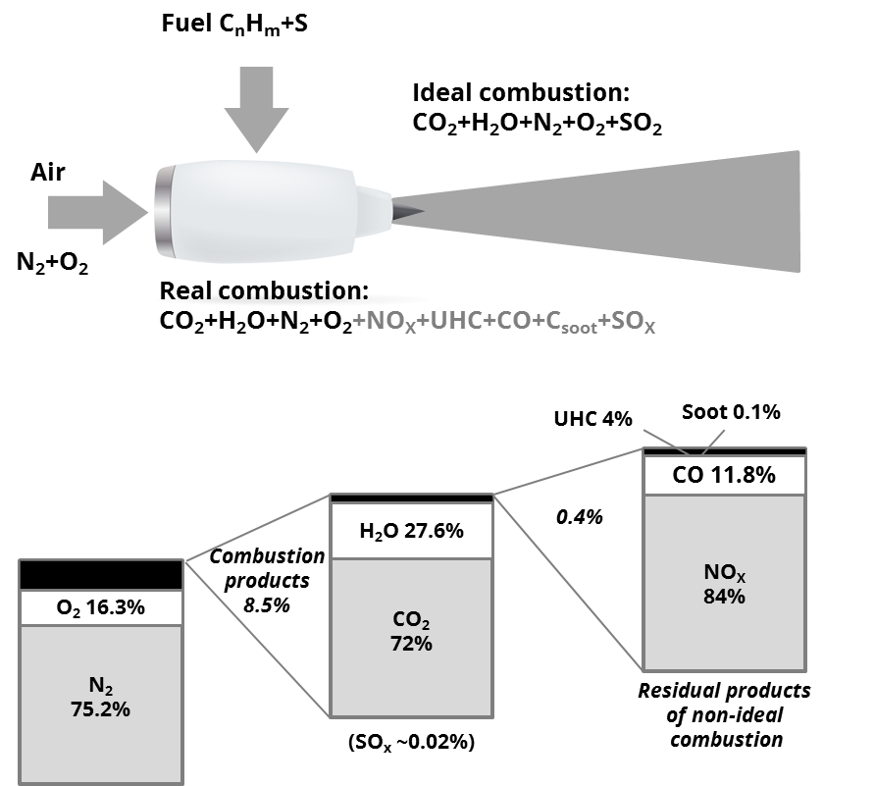

Source: Based on Wuebbles et al., (2007).

Techniques

Aircraft engines
As shown in Figure 2.2, the main types of aircraft engines are:
- reciprocating (piston) engines
- gas turbine engines.
A reciprocating (piston) engine uses piston and crank mechanisms to extract the energy from fuel burnt in a combustion chamber. This drives the propellers to give the aircraft momentum.
A gas turbine engine compresses air before burning fuel in a combustion chamber, thereby heating it. The major part of the energy produced is used for propelling the aircraft, while a minor portion is used to drive the turbine, which drives the compressor. There are three main types of gas turbine engine: jet engines, which include turbojet and turbofan engines; turboprop engines; and turboshaft engines.
Turbojet engines use only energy from the expanding exhaust stream for propulsion, whereas turbofan and turboprop engines use energy from the turbine to drive a fan or propeller, respectively, for propulsion. Turboshaft engines are a form of gas turbine engine that is optimised to produce shaft power rather than thrust. Turboshaft engines are commonly used in applications, such as in helicopters and aircraft auxiliary power units that require a sustained and high-power output, a high degree of reliability, a small size and a low weight.
Note that emissions from aircraft auxiliary power units (APU) are not included in the calculation methodologies described in this chapter.
Figure 2.2 Aircraft engine types
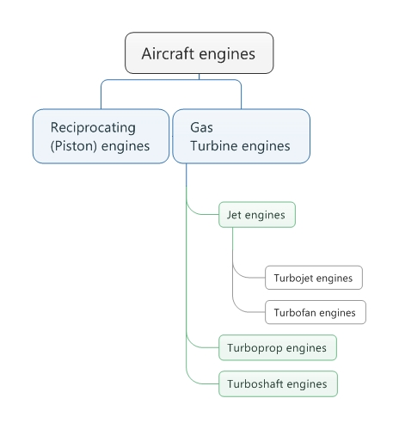
Table 2.1 presents the most-used engine types for each of the most-used aircraft types flying under Instrument Flight Rules (IFR) () in the European airspace in 2015. It shows that 80 % of IFR flight movements in ECAC were performed by only 14 different types of aircraft, which represents only a small percentage of the 546 different types of aircraft identified by EUROCONTROL. Each aircraft is of a type that is designated by an International Civil Aviation Organization (ICAO) code, as defined in ICAO ‘DOC 8643 — Aircraft Type Designators’. For example, B738 designates a Boeing 737-800 (amongst others models of the same type), which is an aircraft with two jet engines.
Table 2.1 Departing flights from ECAC per aircraft type, 2022
ICAO code | Aircraft name | # engines | Mvts (%) | ∑ % mvts | Most-common engine types for the specified aircraft
B738 | BOEING 737-800 | 2J | 31.19% | 31.19% | CFM56-7B, CFM56-7B20, CFM56-7B22, CFM56-7B24, CFM56-7B24E, CFM56-7B26, CFM56-7B26E, CFM56-7B27, CFM56-7B27/B1, CFM56-7B27E, CFM56-7BE
A320 | AIRBUS A-320 | 2J | 23.06% | 54.25% | CFM56, CFM56-5A1, CFM56-5A3, CFM56-5B4/2, CFM56-5B4/2P, CFM56-5B4/3, CFM56-5B4/P, CFM56-5B6/P, V2500-A1, V2527-A5, V2527E-A5
A319 | AIRBUS A-319 | 2J | 6.33% | 60.58% | CFM56-5A4, CFM56-5A5, CFM56-5B5/3, CFM56-5B5/P, CFM56-5B6/P, CFM56-5B7, CFM56-5B7/P, V2522-A5, V2524-A5, V2527-A5, V2527M-A5
A20N | AIRBUS A-320 NEO | 2J | 4.60% | 65.19% | LEAP-1A24, LEAP-1A26, PW1124G-JM, PW1127G-JM
A321 | AIRBUS A-321 | 2J | 2.95% | 68.14% | CFM56-5B1, CFM56-5B1/2P, CFM56-5B3, CFM56-5B3/P, V2530-A5, V2533-A5
AT76 | ATR 72-600 | 2T | 2.13% | 70.27% | PW127F, PW127M
B38M | BOEING 737 MAX 8 | 2J | 1.94% | 72.21% | LEAP-1B
P06T | TECNAM P-2006T | 2P | 1.84% | 74.05% | 912S3
A21N | AIRBUS A-321 NEO | 2J | 1.42% | 75.47% | LEAP-1A30, LEAP-1A32, LEAP-1A33, PW1130G-JM, PW1133G-JM
E195 | EMBRAER 195 | 2J | 1.27% | 76.74% | CF34-10E5A1
DA42 | DIAMOND DA-42 TWIN STAR | 2P | 1.12% | 77.86% | AE300, AUSTRO, CENTURION 1.7
E190 | EMBRAER ERJ-190 LINEAGE 1000 | 2J | 1.10% | 78.96% | CF34-10E
AT75 | ATR 72-500 | 2T | 1.01% | 79.96% | PW127, PW127F
A332 | AIRBUS A-330-200 | 2J | 0.71% | 80.68% | CF6-80E1A2, CF6-80E1A3, CF6-80E1A4, PW4168A, TRENT 772B-60
J, turbofan or turbojet; TP, turboprop.
Source: EUROCONTROL.

Phases of flight
As illustrated in Figure 2.3, the typical flight is composed of several distinct phases of flight; these are:
- taxi-out
- take-off
- climb-out
- climb
- cruise
- descent
- final approach
- landing
- taxi-in.

Figure 2.3 Typical phases of flight
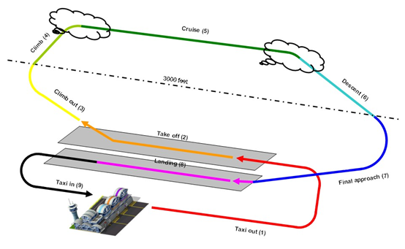
Source: EUROCONTROL
‘Taxi-out’ is the controlled movement of an aircraft on the ground, under its own power, between its parking area and the point of the runway from which its taking-off operations will occur.
‘Take-off’ is the phase of flight in which an aircraft moves from the runway to flying in the air.
‘Climb’ — which in Figure 2.3 is divided into ‘climb-out’ and ‘climb’ — is the phase of flight during which the aircraft ascents to a predetermined cruising altitude after take-off. Although a single climb phase is typical, multiple-step climb phases may also occur.
‘Cruise’ occurs between the climb and descent phases and is usually the longest part of a journey. It ends as the aircraft approaches its destination and the descent phase of the flight commences in preparation for landing. During the cruise phase, because of operational or air traffic control (ATC) reasons, aircraft may climb or descend from one flight level to a higher or lower flight level. During very long flights, aircraft are able to fly higher as the weight of the fuel aboard decreases. Usually, pilots ask ATC to allow them to fly at the optimum flight level for the aircraft they are operating. This optimum flight level is dependent on, for example, the type of aircraft, its operating weight and the length of the flight. ATC generally accept this request if it does not jeopardise safety. For most commercial passenger aircraft, the cruise phase of a flight consumes the majority of the fuel.
‘Descent’ is the phase of flight during which the aircraft decreases its altitude in preparation for landing and is the opposite of the climb phase. As for the climb, descent can be continuous or stepped as a result of operational or ATC reasons; continuous descent is the most fuel-efficient option.
‘Final approach’ is the last leg of an aircraft’s approach to landing, when the aircraft is in line with the runway and descending for landing.
‘Landing’ is the part of a flight when an aircraft returns to the ground up to the point at which taxi-in starts.
‘Taxi-in’ is the movement of an aircraft on the ground, under its own power, that occurs from the point that the aircraft turns off the landing runway (after returning to normal taxi speed) to the point at which it parks on the ground and shuts down its engines.

Activities related to flight movements
For the purposes of this document, a ‘flight movement’ starts when an aircraft begins taxiing out and finishes when the aircraft comes to a stop after taxiing in.
Exhaust emissions from aviation arise from the combustion of jet fuel and aviation gasoline. They arise during all activities related to flight movements and can be grouped into groups of activities as illustrated in Figure 2.4 and listed below:
- pre-departure activities, such as aircraft engine startup and warm-up procedures
- departure activities, such as taxiing, take-off, and initial climb
- climb-cruise-descent (CCD) activities, during which the aircraft maintains a steady altitude and speed for a significant portion of the flight
- emergency activities, such as diversions and go-arounds
- arrival activities, including descent, approach and landing
- post-arrival activities, such as taxiing to the gate and shutting down the engines
- maintenance activities, such as engine runs, equipment testing, and maintenance procedures.

It's important to note that emissions generated during flight operations are not only determined by the type of activity but also by the aircraft technology and fuel efficiency, aircraft weight and altitude.

Figure 2.4 Activities related to flight movements (source: EUROCONTROL)
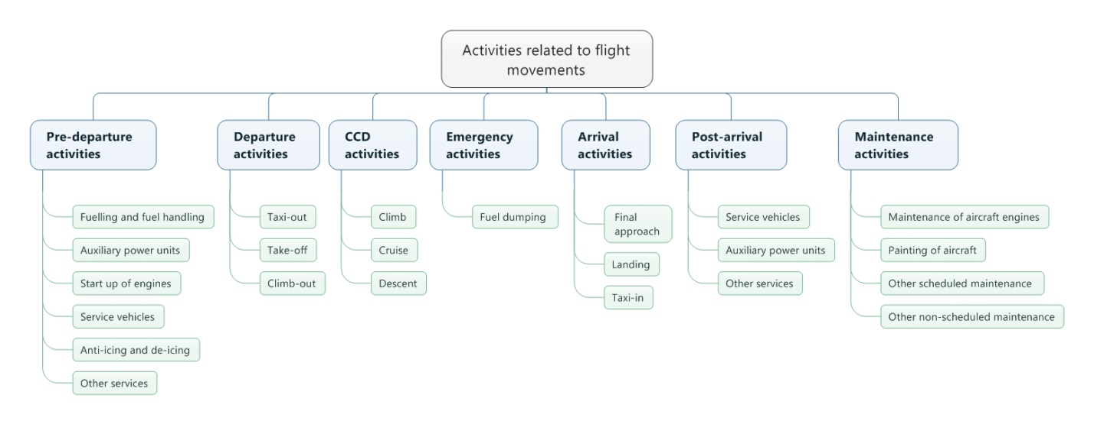
Of the activities related to flight movements listed above, the three main activities for which global fuel usage and emissions inventories are possible are:
- departure activities
- CCD activities
- arrival activities.
As illustrated in Figure 2.5, the different activities related to flight movements are described below.
- Departure includes activities near the airport that take place below a height of 3 000 ft (914.4 m). It includes taxi-out, take-off and climb-out.
- CCD is defined as all activities that take place above 3 000 ft (914.4 m). No upper limit of height is given. CCD includes the climb from the end of the climb-out phase up to the cruise altitude, the cruise and the descent from the cruise altitude to the start of the arrival phase.
- Arrival includes activities near the airport that take place below a height of 3 000 ft (914.4 m). It includes the final approach, landing and taxi-in phases of the flight.

Note
In the aviation inventory domain, activities that take place during the departure and arrival phases of a flight are added and reported together as ‘landing and take-off’ (LTO) activities, while activities that take place during the CCD phases of a flight are added and reported together as ‘Cruise’ activities.

Figure 2.5 Aviation inventory activities versus the typical phases of a flight
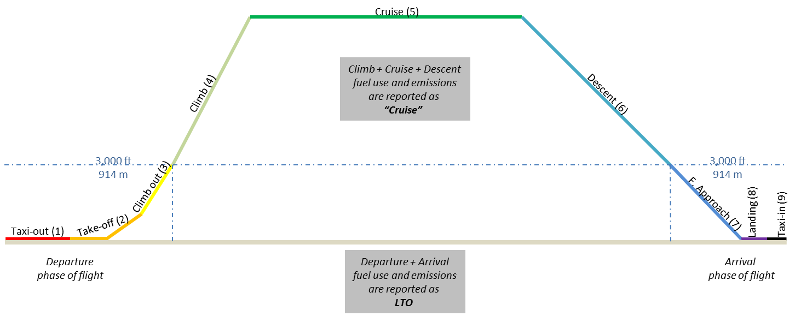
Source: EUROCONTROL

Categories of flights included in aviation inventory activities
In principle, there are four categories of flight movements that should be included in aviation activities in a country. These categories are:
- category 1 — IFR flights;
- category 2 — Civil visual flight rule (VFR) flights, also called general aviation;
- category 3 — Civil helicopters;
- category 4 — Operational military flights.
However, for some categories, a country’s aviation activity data might be scarce or confidential and therefore cannot be included or accounted for as thoroughly as for the other categories. The different categories are described below.
- Category 1 — Civil IFR flights. This is the category from which most emissions originate. Flight movement data are often recorded for this category of aircraft, and methods for estimating the amount of fuel burnt and emissions generated by this category are quite mature. Aircraft in category 1 can be classified according to the type of engine they are equipped with: turbojet, turboprop or piston.
- Category 2 — Civil VFR flights. This category, also known as general aviation, concerns small aircraft used for leisure, agriculture, taxi flights, etc, and rely on visual cues for navigation. Aircraft used for civil VFR flights are generally equipped with turboprop or piston engines.
- Category 3 — Helicopters. This category concerns all types of rotorcraft. Helicopters are often operated under VFR and rarely under IFR. Therefore, it might be difficult to collect precise information on helicopter movements in a country. At present, most helicopters use turboshaft engines to power their rotors, but some small helicopters still use piston engines. It should be noted that the phases of flight schematically represented in Figure 2.3 and Figure 2.5 do not apply to the way in which helicopters manoeuvre.
- Category 4 — Military aircraft. In principle, this category is included in national inventories but the reporting of the emissions from military aircraft is under NFR code 1.A.5, and not 1.A.3.a. However, there may be some difficulties in estimating these activities because of scarce and often confidential military data. Some movements of military aircraft, such as non-operational activities, might be included in category 1.

Contribution from aviation to the combustion emissions from mobile sources
Figure 2.6 summarises the contribution of aviation to the combustion emissions from mobile sources.
Figure 2.6 Contribution from aviation to the combustion emissions from mobile sources
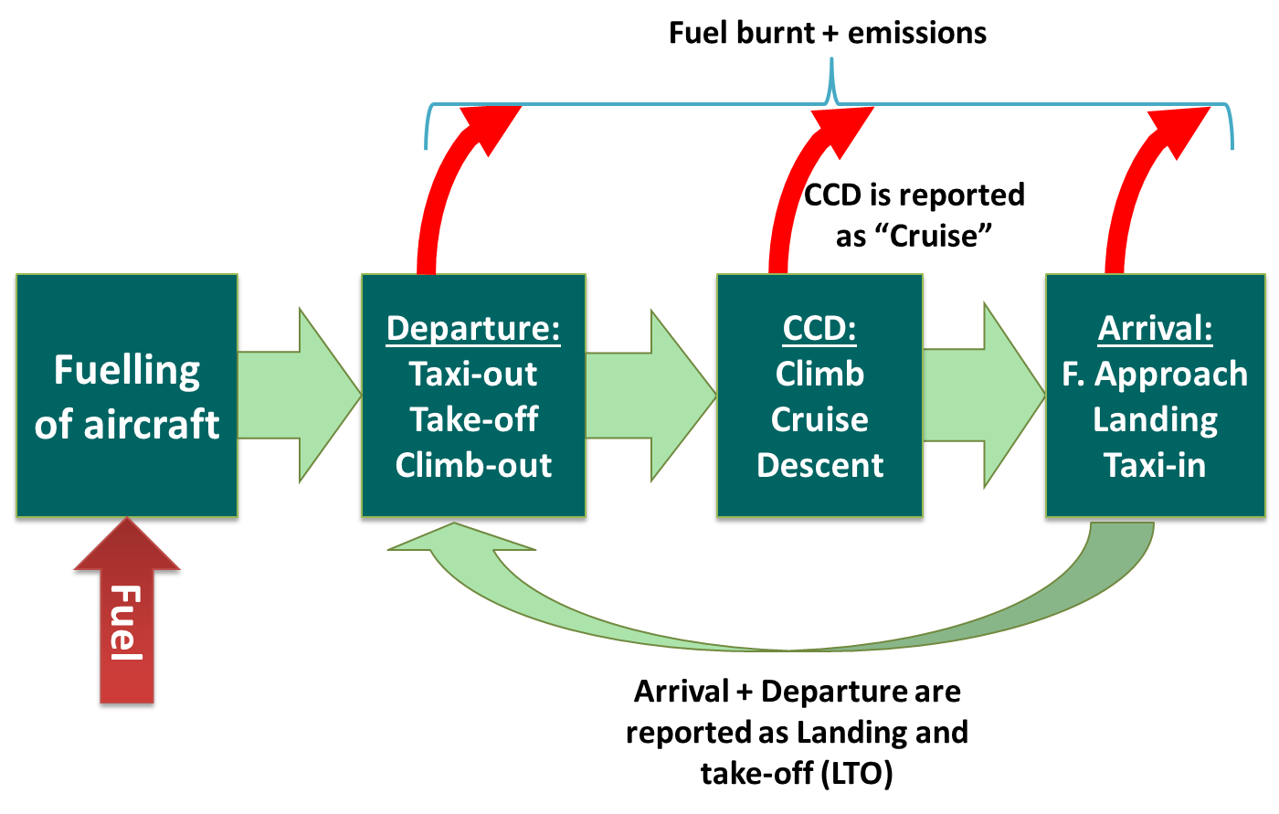
Aviation exhaust emissions are categorised as being ‘International’ or ‘Domestic’ depending on whether the arrival airport is, or is not, in the same state as the departure airport (see Table 3.2).

Controls
The International Civil Aviation Organization (ICAO) primarily addresses environmental concerns through the Committee on Aviation Environmental Protection (CAEP). CAEP assists the ICAO Council with the formulation of new policies and the adoption of new Standards and Recommended Practices (SARPs) related to aircraft noise and emissions, and, more generally, the environmental impact of aviation.
So far, the emission species for which there are ICAO standards (see Annex 16, Volume II) are:
- NO_{x} (most recently updated in 2020);
- CO (most recently updated in 1997);
- unburned HCs (most recently updated in 1984);
- engine smoke,
- CO2 (adopted in March 2020)
- nvPM (adopted in March 2020), end date for the Smoke Number (SN) Standard for engines with rated thrust greater than 26.7 kN.
- Technical work is underway to develop a potential nvPM emissions standard to turbofans/turbojets ≤26.7 kN: – Turboprops, Helicopter turboshaft, and APU engines.

The reader is advised to regularly check the ICAO website (http://www.icao.int/env) for the most recent information about ICAO standards.
The standards published by ICAO, against which engines are certificated, are given in the form of the total quantity of pollutants (D_{p}) emitted in an LTO cycle, divided by the maximum sea level thrust (F_{oo}) and plotted against the engine pressure ratio at maximum sea level thrust.

Table 2.2 shows engine power settings and times-in-mode for the LTO cycle specified by ICAO (ICAO, 2017).

Table 2.2 Default ICAO LTO cycle engine thrust settings and times-in-mode
Operating mode | Thrust setting | Time in operating mode (minutes)
Take-off | 100 % F_{oo} | 0.7
Climb-out | 85 % F_{oo} | 2.2
Approach-landing | 30 % F_{oo} | 4.0
Taxi/ground idle | 7 % F_{oo} | 26.0
The ICAO Aircraft Engine Emissions Databank is maintained by the European Aviation Safety Agency (EASA) on behalf of the ICAO and contains information on exhaust emissions (provided by engine manufacturers) for turbojet and turbofan engines that have entered production (ICAO, 2023).
For turboprop engines, the Swedish Defence Research Agency (FOI) maintains a confidential database of emission indices of NO_{X}, HCs and CO with corresponding fuel flows. The datasheets in this database have been supplied by turboprop engine manufacturers, originally for the purposes of calculating emissions-related landing charges. Access to the database can be requested via a dedicated webpage (FOI, 2016).
The only source for emissions data for piston engine aircraft is provided by the Federal Office of Civil Aviation (FOCA), which is responsible for aviation development and the supervision of civil aviation activities in Switzerland (FOCA, 2007).

Contribution of air traffic to total emissions
Aircraft emissions contribute to global anthropogenic CO₂ emissions, with recent estimates indicating a contribution of around 2.4% and 3.5% contribution to the effective radiative forcing (Lee et al., 2021). It contributed to approximatively 4% to the almost 1.2°C of observed huma-induced global warming to date. While this may seem like a relatively small percentage, it is important to consider that most aircraft emissions are released almost directly into the upper free troposphere and lower stratosphere. The importance of this source is growing as the volume of air traffic is projected to steadily increases despite a stop during the COVID years.
The importance of air traffic in Europe with regard to various air pollutants is illustrated in Table 2.3.

Table 2.3 Percentage contributions made by the aviation sector to national total emissions reported by the EU-27 (EU Member States up to 30 June 2013) for the years 1990 and 2013
 | Domestic and international LTO (%, minimum to maximum) |  | International cruise (%, minimum to maximum) |  | Domestic cruise (%, minimum to maximum)
 | 1990 | 2013 | 1990 | 2013 | 1990 | 2013
CO | 0–0.9 | 0–5.6 | 0–1.1 | 0–1.2 | 0–0.2 | 0–1.4
NMVOC | 0–0.3 | 0–1.7 | 0–1.4 | 0–0.5 | 0–0.2 | 0–0.9
NO_{x} | 0–2.2 | 0–4.3 | 0–3.6 | 0–17 | 0 – 1.0 | 0–2.3
PM₁₀ | 0–1.1 | 0–1.5 | 0–3.1 | 0–4.8 | 0–0.1 | 0–0.2
PM_{2.5} | 0–0.8 | 0–1.9 | 0–5.8 | 0–7.6 | 0–0.1 | 0–0.2
SO_{x} | 0–0.1 | 0–2.7 | 0–1.1 | 0–5.4 | 0–0.2 | 0–0.5

Source: EEA 2015.

Methods

Choice of method

Overview
Figure 3.1 presents the decision tree to follow to determine the appropriate tier method for estimating the total fuel consumption and emissions from aviation. This decision tree is applicable to all nations. When estimating aviation emissions, the following should be considered:
- use as detailed information as is available;
- if the source category is a key source, then a Tier 2 or Tier 3 method must be used to estimate the emissions.
Figure 3.1 Decision tree for determining the appropriate tier method to apply
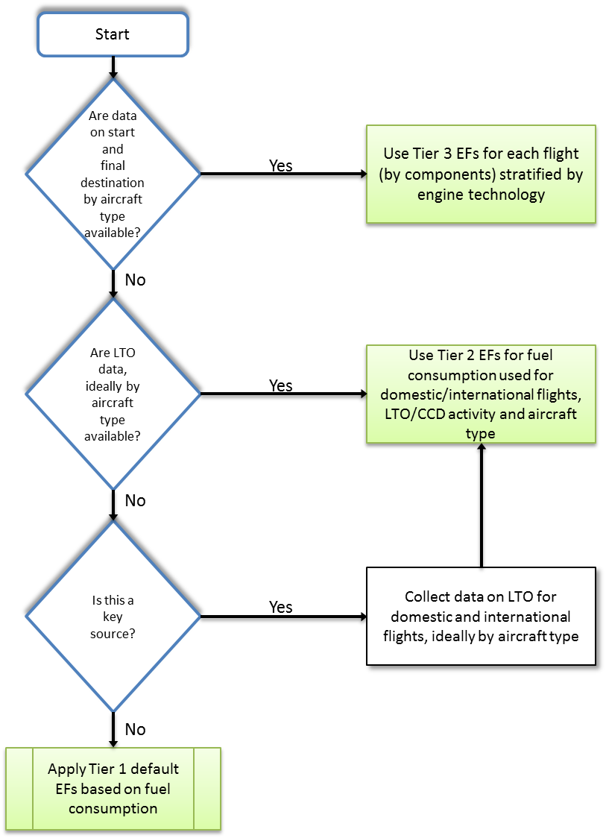
Note: EF – emission factor.
The three tiers are harmonised with those specified in the IPCC 2006 Guidelines (IPCC, 2006).
Table 3.1 summarises the data required for use of the three tiers in terms of activity measures. It will often be the case that the overall emissions for category 2 and 3 flights are sufficiently small and that the statistics available are so poor that a Tier 1 approach for these portions of aviation is appropriate.
Table 3.1 Summary of input data required for the three tiers of inventory methodology
Tier | Activity | Data and tools used
Tier 1 | Fuel sales sub-divided into domestic and international usage  Total LTO numbers for domestic and international | Use average fleet mix (i.e. generic aircraft EFs) and average factors for LTO and CCD
Tier 2 | Fuel sales sub-divided into domestic and international use, as for Tier 1  LTO numbers for domestic and international, per aircraft type | Use of aircraft-specific LTO EFs and average EFs for CCD
Tier 3 | Data for each flight containing aircraft type and flight distance, sub-divided into domestic and international | Tier 3A: Use specific aircraft type/engine data from the spreadsheet accompanying this chapter, available from the 2023 EMEP/EEA air pollutant emission inventory guidebook (EEA, 2016) website  Tier 3B: Use EUROCONTROL Advanced Emission Model (AEM) US/Federal Aviation Administration (FAA) Aviation Environmental Design Tool (AEDT) or similar tools with specific airport taxi times
The Tier 1 and Tier 2 methodologies are based on LTO data and the quantity of fuel sold or used, as illustrated in Figure 3.2. It is assumed that fuel used equals fuel sold. From the total fuel sold for aircraft activities, allocations are made according to the requirements for IPCC and UNECE reporting. The emissions estimation can be made following either the Tier 1 or Tier 2 methodology outlined below.
To estimate the total emissions of CO₂, SO₂ and heavy metals, the Tier 1 methodology is sufficient, as the emissions of these pollutants are dependent on the fuel only and not on the technology. The emissions of PM₁₀ or PM_{2.5} are aircraft and payload dependent. Therefore, when estimating the total emissions of these pollutants, it may be appropriate to consider the aircraft activity in more detail using the Tier 2 methodology. The Tier 3 methodology may be used to get an independent estimate of fuel and CO₂ emissions from domestic and international air traffic.

Figure 3.2 Estimation of aircraft emissions using the Tier 1 and Tier 2 methodologies
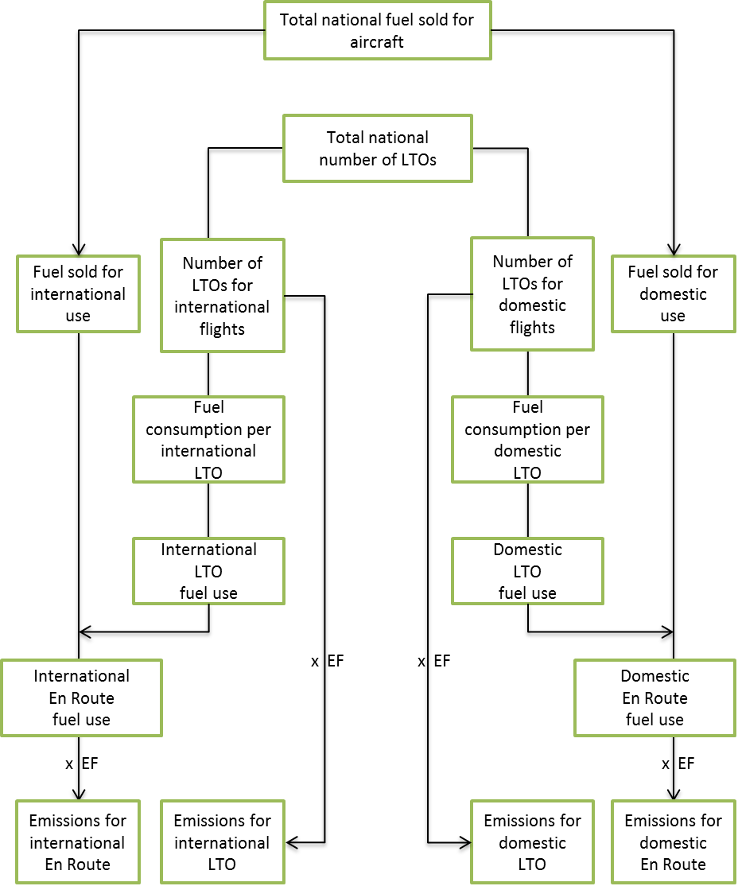

Choice of activity data
The way in which the activity statistics are derived is critical to the difference between Tier 1 and 2. Since emissions from domestic aviation are reported separately from international aviation and for LTO and CCD, it is necessary to disaggregate the activity data for these components. This section lays out options regarding how this should be done — this is also consistent with the approach used to estimate greenhouse gases. The basic starting points are national statistics on fuel consumption and, for Tier 2, data on take-offs and landings with more detailed information about aircraft types/engines.

Domestic and international split
To disaggregate between domestic and international activity data, the definitions outlined in Table 3.2 should be applied irrespective of the nationality of the carrier. For consistency, it is good practice to use similar definitions for domestic and international aviation activities. In some cases, the national energy statistics may not provide data consistent with this definition. It is good practice for countries to separate the activity data, consistent with this definition. In any case, a country must clearly define the methodologies and assumptions used.
Table 3.2 Criteria for defining international or domestic aviation (applies to individual legs of journeys with more than one take-off and landing)
Flight between two airports | Domestic | International
Departs and arrives in the same state | Yes | No
Departs from one state and arrives in another | No | Yes
Note
Based on past experience of compiling aviation emissions inventories, difficulties have been identified regarding the international/domestic split, particularly with obtaining the information on passenger and freight drop-off and pick-up at stops in the same country that was required by the IPPC GHG Guidelines (IPCC 1997, 2006). Most flight data are collected on the basis of individual flight segments (from one take-off to the next landing) and do not distinguish between different types of intermediate stops (as called for in GPG2000). Basing this distinction on flight segment data (origin/destination) is therefore simpler and is likely to reduce uncertainties. It is very unlikely that this change would make a significant change to the emission estimates (). This does not change the way in which emissions from international flights are reported as a memo item that are not included in national totals.
Improvements in technology and optimisation of airline operating practices have significantly reduced the need for intermediate technical stops. An intermediate technical stop would also not change the definition of a flight as being domestic or international. For example, if explicit data are available, countries may define flight segments as international if they depart from one country with a destination in another country and make an intermediate technical stop. A technical stop is solely for the purpose of refuelling or solving a technical difficulty, and not for the purpose of passenger or cargo exchange.
If national energy statistics do not already provide data consistent with this definition, countries should then estimate domestic and international fuel consumption according to the definition, using the approaches set out below.
Top-down data can be obtained from taxation authorities in cases in which fuel sold for domestic use is subject to taxation, but fuel sold for international use is not taxed. Airports or fuel suppliers may have data on the delivery of aviation kerosene and aviation gasoline for domestic and international flights. In most countries tax and custom dues are levied on fuels for domestic consumption, and fuels for international consumption (bunkers) are free of such dues. In the absence of more direct sources of data, information about domestic taxes may be used to distinguish between domestic and international fuel consumption.
Bottom-up data can be obtained from surveys of airline companies for fuel used for domestic and international flights, or estimates from aircraft movement data and standard tables of fuel consumed or both. Fuel consumption factors for aircraft (fuel used per LTO and per nautical mile cruised) can be used for estimates and may be obtained from the airline companies.
Examples of sources for bottom-up data, including aircraft movements, are:
● statistical offices or transport ministries as a part of national statistics;
● airport records;
● ATC records, for example EUROCONTROL statistics;
● air carrier schedules published monthly by independent providers of travel;
● information which contains worldwide timetable passenger and freight aircraft movements, as well as regular scheduled departures of charter operators.
Some of these sources do not cover all flights (e.g. charter flights may be excluded). On the other hand, airline timetable data may include duplicate flights because of code shares between airlines or duplicate flight numbers. Methods have been developed to detect and remove these duplicates (Baughcum et al., 1998; Sutkus et al., 2001).

Military aircraft
Although military aviation is not reported here, it makes sense to include a basic description of the methodology in this chapter, appropriately cross-referenced from the chapter on NFR code 1.A.5.
Military activities are defined here as those activities using fuel purchased by or supplied to the military authorities of the country. Emissions from aviation fuel use can be estimated using the Tier 1 algorithm and the same calculation approach recommended for civilian aviation. Some types of military transport aircraft and helicopters have fuel and emissions characteristics similar to civil types. Therefore, default emission factors for civil aircraft should be used for military aviation unless better data are available. Alternatively, fuel use may be estimated from the hours in operation. Default fuel consumption factors for military aircraft are given in Tables 3.9 and 3.10.
Military aircraft (transport planes, helicopters and fighters) may not have a civilian equivalent, so a more detailed method of data analysis is encouraged if data are available. Inventory compilers should consult military experts to determine the most appropriate emission factors for a country’s military aviation.
Because of confidentiality issues, many inventory compilers may have difficulty obtaining data on the quantity of fuel used by the military. Military activities are defined here as those activities using fuel purchased by or supplied to the military authorities in the country. Countries can apply the rules used to define civilian, national and international aviation operations to military operations if the data necessary to apply those rules are comparable and available. In this case, the international military emissions may be reported under ‘International Aviation’ (‘International Bunkers’), but must then be shown separately. Data on military fuel use should be obtained from government military institutions or fuel suppliers. If data on the international–domestic fuel split are unavailable, all the fuel sold for military activities should be treated as domestic.
Emissions resulting from multilateral operations pursuant to the Charter of the United Nations should not be included in national totals; other emissions related to operations shall be included in the national emissions totals of one or more parties involved. The national calculations should take into account fuel delivered to the country’s military, as well as fuel delivered within that country but used by the military of other countries. Other emissions related to operations (e.g. off-road ground support equipment) shall be included in the national emissions totals in the appropriate source category.
National circumstances may vary, and in particular, distances travelled and fuel consumption may be affected by national route structures, airport congestion and air-traffic control practices.

Tier 1 fuel-based methodology

Algorithm
The Tier 1 approach for aviation is based on fuel consumption data for aviation divided by LTO and for domestic and international flights separately. The method uses a simple approach to estimate the division of fuel use between CCD and LTO, as shown schematically in Figure 3.2.
The Tier 1 approach for aviation emissions uses the following general equation:
(1)
where
E_{pollutant} is the annual emission of pollutant for each of the LTO and CCD phases of domestic and international flights;
AR_{fuel consumption} is the activity rate by fuel consumption for each of the flight phases and flight types; and
EF_{pollutant} is the emission factor of pollutant for the corresponding flight phase and flight type.
This equation is applied at the national level, using annual national total fuel use data disaggregated for domestic and international flights. Information on fuel consumption for domestic and international flights should be available from national statistics, as described above, or is widely available from UN statistical yearbooks or national statistics. Aircraft emissions estimates according to the Tier 1 approach can be obtained by following the steps detailed in sub-section 3.2.3.

Default emission factors
Tier 1 emission factors (EF_{Pollutant}, fuel type) assume an averaged technology for the fleet, and knowledge of the number of domestic and international LTO cycles for the nation. Default fuel and emissions values are presented in the Annex 5 accompanying spreadsheets (‘1.A.3.a Aviation – Annex 5 - Master emission calculator 2016’ and ‘1.A.3.a Aviation – Annex 5 - LTO emissions calculator 2016’) – a representative aircraft type can be selected if detailed flight movement data are not available. If statistics are available for fuel use and the number of LTOs for domestic and international flights, the assumptions on LTO fuel consumption below can be used to divide these data into LTO and CCD data using equation 1.

Total fuel = LTO fuel + CCD fuel (equation 1)

Where:
LTO fuel = number of LTOs × fuel consumption per LTO

CCD fuel = total fuel consumption – LTO fuel consumption
Jet kerosene
Using the relationships above and the data in the accompanying spreadsheets (Annex 5), the emissions for the four different NFR codes can be calculated.
Aviation gasoline
Aviation gasoline is assumed to be used for only domestic aviation. Table 3.3 provides the Tier 1 emission factors for NFR 1.A.3.a.ii.(i): Civil aviation (domestic, LTO) for gasoline-fuelled aircraft. The 95 % confidence limits quoted are 50 % and 200 % of the mean values.
Table 3.3 Tier 1 emission factors for NFR 1.A.3.a.ii.(i): Civil aviation (domestic, LTO)
Tier 1 emission factor
 | Code | Name
NFR Source Category | 1.A.3.a.ii.(i) | Civil aviation (domestic, LTO)
Fuel | Jet Gasoline and Aviation Gasoline
Not applicable | HCH, PCB, HCB
Not estimated | NH3, TSP, PM10, PM2.5, Pb, Cd, Hg, As, Cr, Cu, Ni, Se, Zn, PCDD/F, Benzo(a)pyrene, Benzo(b)fluoranthene, Benzo(k)fluoranthene, Indeno(1,2,3-cd)pyrene
Pollutant | Value | Unit | 95% confidence interval |  | Reference
 |  |  | Lower | Upper
NO_{x} | 4 | kg/tonne fuel | 2 | 8 | Calculated using Tier 2 method
CO | 1200 | kg/tonne fuel | 600 | 2400 | Calculated using Tier 2 method
NMVOC | 19 | kg/tonne fuel | 9.5 | 38 | Calculated using Tier 2 method
SO_{x} | 1 | kg/tonne fuel | 0.5 | 2 | Assuming 0.05% S by mass

Note: If national PM emission factors are available, a BC fraction of PM (f-BC) equal to 0.15 is suggested (for further information see Annex 3).

Calculation steps of the Tier 1 approach
The Tier 1 approach is based on the premise that data on the quantities of fuel sold for aviation use are available, most probably from nationally collected data. It also assumes that the annual quantity of fuel used is the same as that sold.
Information on the country’s total number of LTOs must be available, preferably also the destination (long and short distance) for international LTOs, together with a general knowledge about the aircraft types carrying out aviation activities.
Aircraft emissions estimates according to the Tier 1 methodology can be obtained by following the steps outlined below.
- Obtain the total amount of fuel sold for all aviation (in ktonnes).
- Obtain the amount of fuel used for domestic aviation only (in ktonnes).
- Calculate the total amount of fuel used for international aviation by subtracting the domestic aviation (step 2) from the total fuel sold (step 1).
- Obtain the total number of LTOs carried out for domestic aviation.
- Calculate the total fuel use for LTO activities for domestic aviation by multiplying the number of domestic LTOs by the domestic fuel use factors for one representative aircraft (see Annex 5: ‘1.A.3.a Aviation – Annex 2 - LTO emissions calculator’) (quantity obtained in step 4 multiplied by fuel use for representative aircraft).
- Calculate the fuel used for CCD activities for domestic aviation by subtracting the fuel used for domestic LTO (step 5) from the total domestic fuel used (step 2).
- Estimate the emissions related to domestic LTO activities by multiplying the emission values (per LTO) for domestic traffic with the number of LTOs for domestic traffic. Emission values are suggested for old and average-aged fleet by representative aircraft (see Annex 5: ‘1.A.3.a Aviation – Annex 2 - LTO emissions calculator).
- Estimate the emissions related to domestic CCD activities by multiplying the corresponding emission values (in emissions/fuel used) in 1.A.3.a Aviation – Annex 2 - LTO emissions calculator’ with the domestic CCD fuel use. Emission factors are suggested for an old and an average-aged fleet by representative aircraft.
- Repeat steps 4 to 8 but substitute domestic activities with international activities. For international flights, it is preferable to distinguish between short- (< 1 000 nm ()) and long-distance (> 1 000 nm) flights. The latter is normally performed by large fuel-consuming aircraft compared with the shorter distance flights (e.g. within Europe). If this distinction cannot be made, the LTO emissions are expected to be largely overestimated in most countries.

Tier 2 method

Algorithms
The Tier 2 approach can be applied if it is possible to obtain information on LTOs per aircraft type but there is no information available on CCD distances. Information on the aircraft types used for both domestic and international aviation, together with the number of LTOs carried out by the various aircraft types, is necessary for this methodology.
Apart from this level of further detail according to aircraft type, the algorithms are the same as for the Tier 1 approach:
(2)
where, as before, E_{pollutant} is the annual emission of pollutant for each of the LTO and CCD phases of domestic and international flights; ARfuel consumption, aircraft type is the activity rate by fuel consumption for each of the flight phases and flight types, for each aircraft type; and EF_{pollutant, aircraft type} is the emission factor of pollutant for the corresponding flight phase and flight type, for each aircraft type.

Aircraft-specific fuel used and emission values
Table 3.4 is an extract from the Annex 5 of the aviation chapter “1.A.3.a Aviation – Annex 1 - Master emissions calculator” that lists LTO fuel consumption and emission factors for certain aircraft types with their most frequent engine types. Note that the values provided in Table 3.4 for LTO are based on standard ICAO taxi times and these may differ significantly from average taxi times at European airports. In addition, the Annex 5 of the aviation chapter “1.A.3.a Aviation – Annex 1 - LTO emissions calculator”, provides a means to easily estimate the amount of fuel used and emissions exhausted during the LTO cycles of a large range of aircraft at a particular European airport for a particular year between 2005 and 2022 based on average taxi times. The average taxi time has been provided by EUROCONTROL. The fuel burnt and emission data in both of these spreadsheets have been provided by EUROCONTROL with the aim of supporting the European Union and EU Member States in the maintenance and provision of European and national emission inventories. These fuel burn and emission data are modelled estimates and not 'absolute' values and should not be used for comparing fuel efficiency and emission data between aircraft models and manufacturers. The engine associated to each aircraft type is the most common type of engine used for each aircraft type in 2022.

Table 3.4 Examples of aircraft types and emission values for LTO cycles as well as fuel consumption per aircraft type, in kg/LTO (ICAO default LTO duration: 32 minutes and 54 seconds)
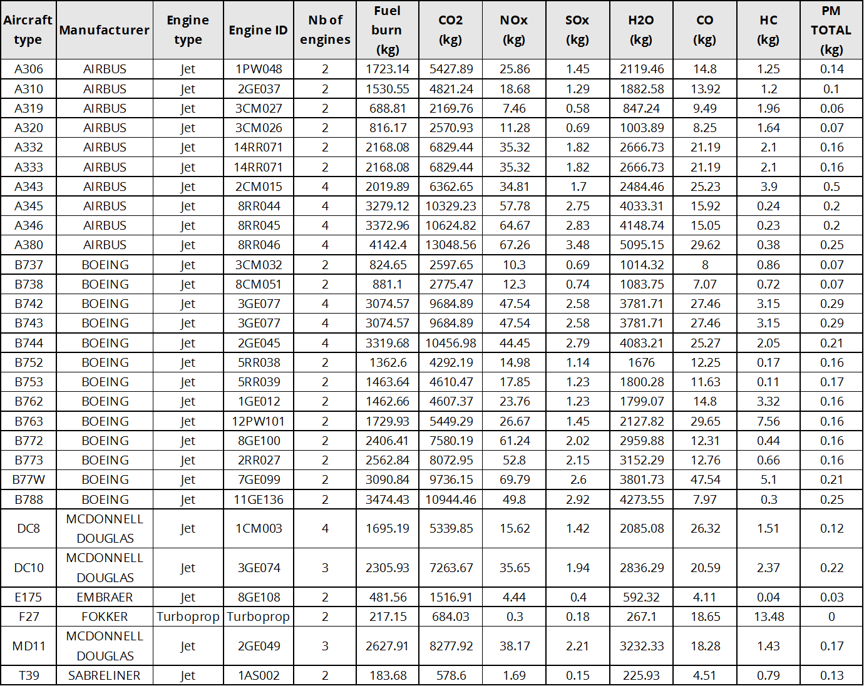
Notes: * Denotes engine types that have been updated or changed from the previous version of the table.
UID – Unique identifier.

Calculation steps for Tier 2
The Tier 2 methodology is predominantly a top-down (fuel-sold) methodology that uses statistics on aviation fuel consumption (split by domestic and international). To split the fuel use by LTO and CCD, detailed LTO activity data and knowledge of aircraft fleet composition are needed to provide a more accurate inventory as opposed to using only average emission factors per mass of fuel used (the Tier 1 approach). The Tier 2 methodology should include all types of aircraft frequently used for domestic and international aviation. The two accompanying spreadsheets (Annex 5) available from the 2023 EMEP/EEA air pollutant emission inventory guidebook (EEA, 2016) website (‘1.A.3.a Aviation – Annex 1 - Master emission calculator’ and ‘1.A.3.a Aviation - Annex 2 - LTO emissions calculator) provide a way of mapping actual aircraft to representative aircraft types in the database.
The approach involves the steps outlined below.
- Obtain the total amount of fuel sold for all aviation (in ktonnes).
- Obtain the total amount of fuel used for domestic aviation (in ktonnes).
- Calculate the amount of fuel used for international aviation by subtracting the domestic aviation (step 2) from the total fuel sold (step 1) (in ktonnes).
- Obtain the total number of LTOs carried out per aircraft type for domestic aviation. As mentioned above in this chapter, the spreadsheet ‘1.A.3.a Aviation Annex 2’ contains data on most aircraft types.
- Calculate the fuel use for LTO activities per aircraft type for domestic aviation. For each aircraft type, multiply the fuel use factor in the spreadsheet accompanying this chapter (Annex 5 ‘1.A.3.a Aviation – Annex 2 - LTO emissions calculator’). The calculations are carried out for all types of generic aircraft. Calculate the total fuel use for LTO activities by summing all contributions found under step 5 for domestic aviation. If some types of national aircraft in use are not found in the table, use a similar type taking into account size and age. For LTOs for smaller aircraft and turboprops, also see section 3.4.1 that includes information on non-IFR flights.
- Calculate the total fuel use for domestic CCD by subtracting the total amount of fuel for LTO activities found in step 6 from the total in step 2 (estimated as for the Tier 1 methodology).
- Estimate the emissions from domestic LTO activities per aircraft type. The number of LTOs for each aircraft type is multiplied by the emission factor related to the particular aircraft type and pollutant. This is done for all generic aircraft types. Relevant fuel use and emission values can again be found in the spreadsheet accompanying this chapter (Annex 5 ‘1.A.3.a Aviation – Annex 2 - LTO emissions calculator’). If some types of national aircraft in use are not found in this spreadsheet, use a similar type taking into account size and age. For LTOs for smaller aircraft, also see the section on non-IFR flights. Their emissions will have to be estimated separately by a simpler method.
- Estimate the emissions from domestic CCD activities. Use the domestic CCD fuel use and the corresponding emission factor for the most common aircraft type used for domestic CCD activities (the Tier 1 or Tier 3 methodology). Relevant fuel use and emission values can be found in the accompanying spreadsheet for the Tier 3 methodology (‘Annex 5 ‘1.A.3.a Aviation – Annex 2 - LTO emissions calculator’).
- Calculate the total emissions for LTO activities for domestic aviation. Add all contributions from the various aircraft types as found under step 7. The summations shall take place for each of the pollutants for which emissions are to be estimated (for CO₂, NO_{x}, SO₂, etc.).
- Calculate the total emissions for CCD activities for domestic aviation. Add all contributions from the various aircraft types as found under step 8. The summations shall take place for each of the pollutants for which emissions are to be estimated (for CO₂, NO_{x}, SO₂, etc.).
- Repeat the calculation (steps 4–10) for international aviation.

Abatement
The technology abatement approach is not relevant for this methodology.

Military aircraft
The Tier 2, that is, aircraft type-specific, methodology is also applicable to the calculation of the emissions from military aircraft. However, it should be noted that the reporting of emissions from military aircraft is under NFR code 1.A.5, not 1.A.3.a.
There are two potential activity indicators:
- total fuel used by military aircraft;
- number of flight hours per aircraft type, multiplied by average fuel consumption in kg/hour.
The accompanying Annex 5 spreadsheets ‘1.A.3.a Aviation – Annex 1 - Master emission calculator’ and ‘1.A.3.a Aviation - Annex 2 - LTO emissions calculator’ provide some generic and aircraft-specific fuel consumption data for military aircraft. The emission factors given in the abovementioned spreadsheets (which are per unit of fuel combusted) can then be used with the fuel-used data to calculate emissions.
Table 3.5 Fuel consumption factors for generic military aircraft
Group | Sub-group | Representative type | Fuel flow (kg/hour)
1. Combat | Fast jet — high thrust  Fast jet — low thrust | F16  Tiger F-5E | 3 283  2 100
2. Trainer | Jet trainers  Turboprop trainers | Hawk  PC-7 | 720  120
3. Tanker/transport | Large tanker/transport  Small transport | C-130  ATP | 2 225  499
4. Other | MPAs, maritime patrol | C-130 | 2 225
Source: ANCAT, British Aerospace/Airbus.

Table 3.6.Fuel consumption per flight hour for specific military aircraft
Aircraft Type | Aircraft description | Fuel use  (litres per hour)
A-10A | Twin engine light bomber | 2 331
B-1B | Four engine long-range strategic bomber; used by USA only | 13 959
B-52H | Eight engine long-range strategic bomber; used by USA only | 12 833
C-12J | Twin turboprop light transport; Beech King Air variant | 398
C-130E | Four turboprop transport; used by many countries | 2 956
C-141B | Four engine long-range transport; used by USA only | 7 849
C-5B | Four engine long-range heavy transport; used by USA only | 13 473
C-9C | Twin engine transport; military variant of DC-9 | 3 745
E-4B | Four engine transport; military variant of Boeing 747 | 17 339
F-15D | Twin engine fighter | 5 825
F-15E | Twin engine fighter-bomber | 6 951
F-16C | Single engine fighter; used by many countries | 3 252
KC-10A | Three engine tanker; military variant of DC-10 | 10 002
KC-135E | Four engine tanker; military variant of Boeing 707 | 7 134
KC-135R | Four engine tanker with newer engines. Boeing 707 variant | 6 064
T-37B | Twin engine jet trainer | 694
T-38A | Twin engine jet trainer; similar to F-5 | 262

Tier 3 flight- and aircraft-type methodology
The Tier 3 methodologies are based on actual flight movement data, either for Tier 3A origin and destination (OD) data or for Tier 3B full flight trajectory information. These methodologies are bottom-up, flight-based, rather than top-down calculation-based, on the fuel consumed. An example of a system implementing a Tier 3 methodology is provided in Annex 4.
Tier 3A takes into account CCD emissions for different flight distances. Consequently, details on the origin (departure) and destination (arrival) airports and aircraft type are needed to use this approach, for both domestic and international flights. In Tier 3A, inventories are modelled using average fuel consumption and emissions data for the LTO phase and various CCD phase lengths, for an array of representative aircraft categories.
The Tier 3A methodology takes into account that the quantity of emissions generated varies between phases of flight. It also takes into account that fuel burn is related to flight distance, while recognising that this fuel burn can be comparably higher over relatively short distances than on longer routes. This is because aircraft use more fuel per distance for the LTO cycle compared with the ‘en-route’ phase.
The Tier 3B methodology is distinguished from the Tier 3A methodology by the calculation of fuel burnt and emissions throughout the full trajectory of each flight segment using aircraft- and engine-specific aerodynamic performance information. To use Tier 3B, sophisticated computer models are required to address all the equipment, performance and trajectory variables and calculations for all flights in a given year.
Models used for Tier 3B calculations can generally specify output in terms of the aircraft, engine, airport, region and global totals, as well as by latitude, longitude, altitude and time, for fuel burnt and emissions of CO, HCs, CO₂, H₂O, NO_{x} and SO_{x}. To be used in preparing annual inventory submissions, a Tier 3B model must calculate aircraft emissions from input data that take into account air-traffic changes, aircraft equipment changes or any input-variable scenario.
Ideally, the components of Tier 3B models should be designed to be readily updated so that the models are dynamic and can remain current with evolving data and methodologies. A list of Tier 3B models can be found on the ICAO CAEP Modelling and Databases Group (MDG) web page ().
The Tier 3 methodology described in this chapter only relates to Tier 3A.

Tier 3A fuel use and emission values
As for Tier 2 emissions, the values for CO₂, SO₂ and heavy metals are based on the fuel used, and PM values are calculated from the PM_{2.5} emissions. The emissions of NO_{x}, HC, CO and smoke, as well as the fuel used, are calculated on a flight-by-flight basis using emission values available from the accompanying Annex 5 spreadsheets to the chapter, which are available from the 2023 EMEP/EEA air pollutant emission inventory guidebook (EEA, 2016) website.
Instrument flight rules (IFR) flights
The fuel used and emission values for the Tier 3 methodology for more than 250 jets and turboprop engines and for different flight distances are provided in the spreadsheet accompanying this chapter; this spreadsheet is available from the 2023 EMEP/EEA air pollutant emission inventory guidebook (EEA, 2016) website.

Note: The fuel burnt and emissions data provided in the accompanying Annex 5 spreadsheets are to assist the EU and EU Member States in the maintenance and provision of European and national homogeneous emissions inventories. These data should not be used to compare fuel efficiency and emissions data between aircraft models and manufacturers.

Note: The updated fuel burnt and emissions values provided in the spreadsheet accompanying this chapter were calculated by using the EUROCONTROL Impact noise and emissions model to derive/generate the ‘more fuel efficient’ trajectory for each couple (aircraft airframe/engine(s)) selected for a selection of stage lengths within maximum observed stage length for this aircraft airframe, then by processing the trajectories obtained with the EUROCONTROL Advanced Emission Model (AEM) (version 2.6.0) in stand-alone mode, for calculating the fuel burnt and emissions values. A detailed description of how these data were calculated is provided in the spreadsheet itself, as well as the exact list of the aircraft airframe and engine(s) pairs covered.
Table 3.7 Illustrative spreadsheet output for a Boeing 737-400 equipped with two 1CM007 engines.
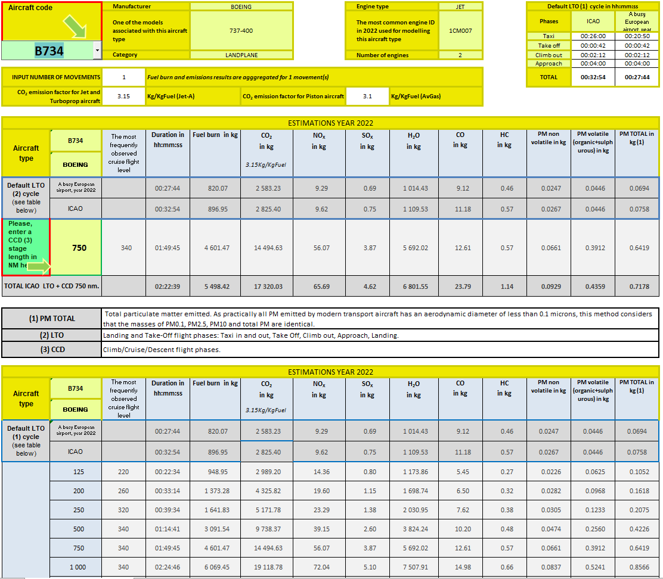

Note: The values provided for LTO in Table 3.10 are based on standard ICAO taxi times. These may differ significantly from average taxi times at European airports. The Annex 5 spreadsheet ‘1.A.3.a Aviation 2 LTO emissions calculator 2023 available from the 2023 EMEP/EEA air pollutant emission inventory guidebook (EEA, 2016) website provides the means to calculate fuel used and emissions LTO values for all European airports from 2005 to 2022.

Non-Instrument Flight Rules (non-IFR) flights
There is little information available on emission factors for non-IFR flights and it is, at present, not possible to recommend default emission factors. Generally, the NO_{x} emission factors will be lower than for IFR flights and the CO and VOC factors substantially higher.
Fuel consumption factors are given for two categories of aircraft (Cessna and others) and these should be used if other information on fuel used is not available (Table 3.8 and Table 3.9). Please note that the tables apply to single-engine aircraft only. If the aircraft is fitted with two engines (e.g. Cessna 500), then the fuel consumption should be doubled. Ranges of emission factors are shown in MEET (1997). A summary is given in Table 3.10.
Some emission factors and fuel-use factors for helicopters and military flights are given in Table 3.11, Table 3.12 and Table 3.13. Also note that many types of military aircraft may have civil equivalents.
Table 3.8 Fuel consumption for piston-engined aircraft
Cessna C 152, C 172 and C 182  (single engine) | Altitude
 | 0 ft | 2 000 ft | 4 000 ft
75 % power (= 135 horsepower (HP) | 41 litre/hour | 42 litre/hour | No data
70 % power (= 126 HP) | 37 litre/hour | 38 litre/hour | 39 litre/hour
65 % power (= 117 HP) | 33.5 litre/hour | 34 litre/hour | 34.5 litre/hour
Note: For an average, use 36 litre/hour.

Table 3.9 Fuel consumption for non-Cessna aircraft
Robin (French aircraft), various Piper types (single engine) | Altitude
 | 0 ft | 4 000 ft
70 % power | 36.5 litre/hour | No data
64 % power | 34 litre/hour | 33.5 litre/hour
58 % power | 31 litre/hour | 31 litre/hour
Note: For an average, use 33 litre/hour.

Table 3.10 Examples of emission factors for piston-engined aircraft in g/kg fuel
Piston-engine aircraft type | NO_{x} | HC | CO | SO₂
Netherlands FL 0–30 | 2.70 | 20.09 | 1 054 | 0.21
FL 30–180 | 4.00 | 12.50 | 1 080 | 0.17
Germany | 3.14 | 18.867 | 798 | 0.42
Note: Multiply FL by 100 to obtain the altitude in ft .
Source: MEET (1997).

Table 3.11 Examples of emission factors for helicopters and military flights in selected countries g/kg fuel
Country | Nature of flights | NO_{x} | HC | CO | SO₂
Germany | LTO cycle | 8.3 | 10.9 | 39.3 | 1.1
 | Helicopter CCD | 2.6 | 8.0 | 38.8 | 1.0
 | Combat jet | 10.9 | 1.2 | 10.0 | 0.9
 | Cruise 0.46–3 km | 10.7 | 1.6 | 12.4 | 0.9
 | Cruise > 3 km | 8.5 | 1.1 | 8.2 | 0.9
Netherlands | Average | 15.8 | 4.0 | 126 | 0.2
 | F-16 | 15.3 | 3.36 | 102 | 0.2
Switzerland | LTO cycle | 4.631 | 2.59 | 33.9 | 1.025
 | CCD | 5.034 | 0.67 | 14.95 | 0.999
Notes: If national PM emission factors are available, a BC fraction of PM (f-BC) of 0.48 is suggested (for further information see Annex 3).
Source: MEET (1997).
Table 3.12 Emission factors for helicopters of selected countries in g/kg fuel
Country | NO_{x} | HC | CO | SO₂
Germany: CCD | 2.6 | 8.0 | 38.8 | 0.99
Netherlands: CCD | 3.1 | 3.6 | 11.1 | 0.20
Switzerland | 13.3 | 0.3 | 1.1 | 0.97
Source: MEET (1997).

Table 3.13 Fuel consumption factors for military aircraft
Group | Sub-group | Representative type | Fuel flow kg/hour
1. Combat | Fast jet — high thrust  Fast jet — low thrust | F16  Tiger F-5E | 3 283  2 100
2. Trainer | Jet trainers  Turboprop trainers | Hawk  PC-7 | 720  120
3. Tanker/transport | Large tanker/transport  Small transport | C-130  ATP | 2 225  499
4. Other | MPAs, maritime patrol | C-130 | 2 225
Source: ANCAT, British Aerospace/Airbus.

Tier 3A algorithm
The Tier 3A methodology is based on actual flight movement data.
The amount of fuel used and emission species are calculated using the emission values described in sub-section 3.4, and the flight movement data obtained nationally or through organisations collecting such information.
Instrument flight rules (IFR) flights
The total emissions from aircraft are given by the sum of emissions from various technologies of aircraft in a continuous set of flying modes. In this methodology, the calculations are simplified by classifying the aircraft into a representative set of generic aircraft types and into two classes of flying modes: LTO and CCD. However, the methodology allows adjustment for actual times-in-mode of LTO at individual airports. This method also permits the use of individual aircraft/engine combinations if data are available.
The methodology involves the steps outlined below.
- Collect flight details from national data, for example civil aviation records, airport records, from the EUROCONTROL agency in Europe or the schedule timetable. This will identify the aircraft that were used in the inventory period, the number of LTOs for each and the distance flown.
- For the aircraft actually flying, select the aircraft used to represent these aircraft from the table of equivalent aircraft (‘1.A.3.a Aviation annex 1’ and ‘1.A.3.a Aviation annex 2’). This is called the ‘representative aircraft’. See also sub-section 0 on ‘Non-Instrument Flight Rules flights’ below. Their emissions will have to be estimated separately by a simpler method.
- See sub-section 3.1.2 ‘Choice of activity data’ for a description of how activity data can be determined.
- From the attached spreadsheet (available from the 2023 EMEP/EEA air pollutant emission inventory guidebook (EEA, 2016) website), select an aircraft type. The spreadsheet will automatically provide the fuel used and the emissions data corresponding to the LTO phase for the representative aircraft, as well as the fuel used and the amount of emissions data for the CCD portion of the flight for a series of pre-determined stage lengths.
- For a specific distance not listed in the pre-determined stage lengths, simply enter the distance in the ‘CCD stage length box’ and the spreadsheet will automatically perform a linear interpolation to calculate the corresponding amount of fuel used and the emissions.
- The total quantity of fuel used for the flight is the sum of the fuel used for LTO plus the fuel used for the CCD portion of the flight.
- The total level of pollutants emitted during the flight is the sum of the pollutants emitted in the LTO phase plus the quantity emitted in the CCD portion of the flight.
The use of energy, and therefore emissions, depends on the aircraft operations and the time spent at each stage. Table 2.2 shows engine power settings and times-in-mode for the LTO cycle, as specified by ICAO (2017). The actual operational time-in-mode might vary from airport to airport depending on the traffic, environmental considerations, aircraft types and topographical conditions. The proportion of fuel used in a flight which is attributed to LTO decreases as the flight distance increases. Thus, a substantial part of the fuel consumption takes place outside the LTO cycle. Studies indicate that the majority of NO_{x} (60–80 %), SO₂ and CO₂ (80–90 %) is emitted at altitudes above 1 000 m: for CO it is about 50 %, and for VOC it is about 20–40 % (Olivier, 1991).
If times-in-modes are different from the assumptions made in this report, corrections may be made from basic data in the accompanying spreadsheets.
Please note that the total estimated fuel use for domestic aviation must be compared with sales statistics or direct reports from the airline companies. If the estimated fuel use deviates from the direct observations, the main parameters used for estimating the fuel must be adjusted in proportion to ensure that the mass of fuel estimated is the same as the mass of fuel sold.
Non-Instrument Flight Rules (non-IFR) flights
For some types of military or pleasure aircraft, the number of hours in flight is a better activity indicator for estimating the fuel used and the emissions produced than the number of LTOs. In some cases, data on the quantity of fuel used may be directly available.
Information on fuel used should be compiled by aircraft category. The fuel types, kerosene and aviation gasoline, should be reported separately. If data are not directly available, estimate the fuel used from the hours of operation and fuel consumption factors.
The appropriate emission factors and fuel use factors should be selected from Table 3.9 to Table 3.13.
To obtain an annual emissions estimate, the fuel consumption data in tonnes should be multiplied by the fuel-based emission factors.

Emission species profiles
Since very few experiments that have analysed the exhaust gas from aircraft turbines in detail have been reported, it is not possible to give a specific emission species profile. In terms of NO_{x} and VOCs, the profiles vary with the thrust setting of the aircraft and therefore depend on the activity. In terms of aircraft CCD, it is not possible to obtain accurate estimates for emission factors.
In terms of the LTO activity, the situation is similar. Attempts have been made to estimate the composition of the VOC profile. The USEPA (2009) reports a VOC profile for aircraft equipped with turbofan, turbojet and turboprop engines, based on Knighton et al. (2009). This composition is presented in Table 3.14.
Please note that the thrust setting during the landing and the take-off of the aircraft are different (see Table 2.2). Therefore, it is likely that the species profile will be different for these two situations.
Table 3.14 Speciated gas phase profile for aircraft equipped with turbofan, turbojet and turboprop engines
Notes: Values in this table may be revised in the future as additional engine data become available.
(a) CAS, Chemical Abstracts Service.
(b) See discussion of unidentified species in section 2.1 of this report.
(c) For commercial, military, general aviation and air taxi aircraft equipped with turbofan, turbojet and turboprop engines.
(d) Identified as a hazardous air pollutant in Section 112 of the U.S. Clean Air Act (shaded above).
(e) Identified in US EPA’s Integrated Risk Information System (IRIS) as having toxic characteristics (shaded above).
(f) Values were adjusted from those shown in knoghton et al. (2009) to account for rounding and to facilitate inclusion of the data in the US EPA’s Speciate database (where the required sum of the values is 1.00000).
Source: USEPA (2009).

Data quality

Completeness
Regardless of method, it is important to account for all fuel used for aviation in the country. The methods are based on total fuel use, and should completely cover CO₂ emissions. However, the allocation between LTO and CCD will not be complete for the Tier 2 method if the LTO statistics are not complete. In addition, the Tier 2 method focuses on passenger- and freight-carrying scheduled and charter flights, and thus not all aviation. Furthermore, the Tier 2 method does not automatically include non-scheduled flights and general aviation such as that involving agricultural aeroplanes, private jets or helicopters, which should be added if the quantity of fuel is significant. Completeness may also be an issue if military data are confidential; in this situation, it is good practice to aggregate military fuel use with another source category.
Other aviation-related activities that generate emissions include fuelling and fuel handling in general, maintenance of aircraft engines and fuel jettisoning to avoid accidents. In addition, in the wintertime, anti-ice and de-ice treatment of wings and aircraft is a source of emissions at airport complexes. Many of the materials used in these treatments flow off the wings when planes are idling, taxiing and taking off, and then evaporate. These emissions are, however, very minor and specific methods to estimate them are not included.
There are additional challenges with regard to distinguishing between domestic and international emissions. As each country’s data sources are unique for this category, it is not possible to formulate a general rule regarding how to make an assignment in the absence of clear data. It is good practice to clearly specify the assumptions made so that the completeness can be evaluated.
In addition, the following sub-sections provide additional information on what is not included in the methods.

Emissions from start-up of engines
There is currently little information available for the estimation of emissions from the start-up of engines, and these are not included in the LTO cycle. This is not of great importance for total national emissions, but they may have an impact on air quality in the vicinity of airports.

Auxiliary power operations
Auxiliary power units (APUs) are used when no other power source is available for the aircraft, and may vary from airport to airport. This is the case, for example, if the aircraft is not parked in the vicinity of the terminal building. The APU fuel use and the related emissions should be allocated on the basis of aircraft operations (number of landings and take-offs). However, no methodology for this has yet been developed. The use of APUs is severely restricted at some airports to maintain high levels of air quality, and therefore this source of fuel use and emissions may be declining. In total terms, the fuel consumption and emissions contribution from this source is regarded as very small (Winther et al., 2006).

Fuel dumping in emergencies
From time to time, aircraft will have to dump fuel before landing so that they do not exceed a certain maximum landing weight. This is done at a location and altitude at which there will be no local impact at ground level. Only large long-range aircraft will dump fuel. NMVOC emissions might become significant at very large airports with frequent long-distance flights. However, since the most probable altitude of these emissions will be above 1 000 m, these are currently not relevant for UNECE reporting. The airport authorities and airline companies might give information on the extent (frequency and amount) of dumping and the altitude at particular airports.

Double counting with other sectors
Emissions and fuel burnt from over-flights are excluded from these calculations to avoid double counting of emissions.

Verification
The methodology presented here could be used with international flight statistics (e.g. ATC providers) to provide a crosscheck against estimates made by individual national experts on the basis of national fuel and flight statistics.
National estimates may be checked against scientific or central inventories.
Estimated emissions and fuel use per available seat per kilometre travelled may also be compared between countries and aircraft types to ensure the credibility of the data that have been collected.

Uncertainty assessment
The uncertainties related to the estimated aircraft emissions are closely associated with the emission factors assigned to the estimations.
The emissions of CO₂ (and fuel use) are generally determined with a higher accuracy than the other pollutants.

Tier 1 approach
The accuracy of the distribution of fuel between domestic and international will depend on the national conditions.
The use of ‘representative’ emission factors may contribute significantly to the uncertainty. In terms of the factors relating to the LTO activities, the accuracy is better than for CCD (because of the origin of the factors from which the average values are derived). It would be hard to calculate a quantitative uncertainty estimate. The uncertainty may however lie between 20 and 30 % for LTO factors and 20 and 45 % for the CCD factors.

Tier 2 approach
The accuracy of the distribution of fuel between domestic and international will depend on the national conditions. The uncertainties lie mainly in the origin of the emission factors. There is a high uncertainty associated with the CCD emission factors.

Tier 3 approach
Uncertainties lie in the emission factors for the engines. ICAO (1995) estimated that the uncertainties of the different LTO factors are approximately 5–10 %. For CCD, the uncertainties are assumed to be 15–40 %.

Inventory quality assurance/quality control (QA/QC)
There are no specific issues relating to inventory quality assurance/quality control.

Gridding
Airports and emissions should be associated with the appropriate territorial unit (e.g. country). The airports can be divided into territorial units in the following way.
- The fuel and emissions from specific airports can be identified, and then summed to show the emissions from the region, which in turn can be summed for a country as a whole. Airports located in the various territorial areas should be identified.
- From the total national emissions estimate, emissions can be distributed to the territorial areas and airports using a key to reflect the aviation activity (e.g. the number of LTO cycles) between territorial areas and airports.

Reporting and documentation
There are no specific issues relating to reporting and documentation.

Areas for improvements in current methodology
The sub-sections below summarise causes for concern and areas in which further work may be required.

Landing and take-off (LTO)
A key priority is to update the fuel consumption and emission factors with data from the ICAO Aircraft Engine Emissions Databank maintained by EASA, in order to better reflect the emissions performance of the aircraft in use today.
Estimates of fuel used and emissions based on ICAO cycles (ICAO, 2017) may not reflect accurately the situation of aircraft and airport operations in Europe.
The relationship between the minor pollutants and the regulated pollutants (HC, CO and NO_{x}) may need to be investigated in more detail.

Emissions above 3 000 ft (914.4 m)
A key priority is to update the fuel consumption and emission factors in order to better reflect the emissions performance of aircraft in use today. The proposed EUROCONTROL fuel burn and emissions calculation tool (AEM) uses EUROCONTROL’s Base of Aircraft Data (BADA) for calculating fuel burnt and emissions above 3 000 ft (EUROCONTROL, 2023a and 2023b). This database contains altitude- and attitude-dependent performance and fuel burn data for more than 200 types of aircraft.
It should be noted that the emission factors and fuel use for short distances (125 and 250 nm) are difficult to model and the suggested values are highly uncertain.

Particulate matter emissions, including PM_{2.5}
There is are inconsistencies between PM emission fractions (i.e. total suspended particulate matter (TSP), PM₁₀ and PM_{2.5}) reported by CLRTAP Parties to the EMEP CEIP, evident by there being variable ratios of PM_{2.5} to TSP and PM_{2.5} to PM₁₀. The most common value reported is 1.00, that is, it is assumed that all PM emissions from aircraft can be viewed as PM₁₀. This is the relationship assumed in this guidebook.

Glossary and acronyms
AEDT Aviation Environmental Design Tool of FDA
AEED Aircraft Engine Emissions DataBank of ICAO
AEM Advanced Emission Model
ANCAT Abatement of Nuisance Caused by Air Transport, a technical committee of the European Civil Aviation Conferences (ECAC)
APU auxiliary power unit
ATC Air traffic control
ATM Air traffic management
BADA Base of Aircraft Data of EUROCONTROL
BFFM2 Boeing Fuel Flow Method 2
CAEP Committee on Aviation Environmental Protection of ICAO
CCD Climb/cruise/descent phases of flights, also referred to as ‘Cruise’ or ‘En route’
EASA European Aviation Safety Agency
EECCA Eastern Europe, Caucasus and Central Asia
FAA U.S. Federal Aviation Administration
FEIS Fuel Burn and Emissions Inventory System of EUROCONTROL
FOA3 First Order Approximation version 3
FOCA Swiss Federal Office of Civil Aviation
FOI Swedish Defence Research Agency
ICAO International Civil Aviation Organization
IFR Instrument Flight Rules
LTO Landing/take-off
MDG Modelling and Databases Group of ICAO CAEP
OD Origin and destination
SARP Standards and Recommended Practice
STATFOR Statistics and Forecasts of EUROCONTROL
VFR Visual flight rules
UID Engine Unique Identification Number

References
Agrawal, H., Sawant, A. A, Jansen, K., Miller, J. W. and Cocker III, D. R., 2008, ‘Characterization of chemical and particulate emissions from aircraft engines’, Atmospheric Environment, (42) 4380–4392 (https://doi.org/10.1016/j.atmosenv.2008.01.069) accessed 5 April 2023.

ANCAT, 1998, ANCAT/EC2 global aircraft emission inventories for 1991/1992 and 2015, Report by the ECAC/ANCAT and EC working group, Gardner, R. (ed.).
Baughcum, S., Tritz, T.G., Henderson, S.C. and Pickett, D.C. 1996, Scheduled aircraft emission inventories for 1992: Database development and analysis, NASA contract report No 4700, NASA Langley Research Centre, Hampton, VA, (https://ntrs.nasa.gov/citations/19960038445) accessed 5 April 2023.
Baughcum, S. L., Sutkus Jr., D. J. and Hendersonm, S. C., 1998, Year 2015 aircraft emission scenario for scheduled air traffic, NASA-CR-1998-207638. (https://ntrs.nasa.gov/archive/nasa/casi.ntrs.nasa.gov/19980055200.pdf) accessed 5 April 2023.
Döpelheuer, A., og M. Lecht (1998): Influence of engine performance on emission characteristics. RTO AVT Symposium on ‘Gas Turbine Engine Combustion, Emissions and Alternative Fuels’. NATO Research and Technology Organization. RTO meeting proceedings.
EASA, EEA and EUROCONTROL, 2022, European aviation environmental report 2022 (EAER | EASA Eco (europa.eu), accessed 05 April 2023.

EEA, 2016, EMEP/EEA air pollutant emission inventory guidebook, European Environment Agency (http://www.eea.europa.eu/themes/air/emep-eea-air-pollutant-emission-inventory-guidebook), accessed 19 July 2019.
EEA, 2016, European Union emission inventory report 1990–2013 under the UNECE Convention on Long-range Transboundary Air Pollution (LRTAP), European Environment Agency, (https://www.eea.europa.eu//publications/lrtap-emission-inventory-report) accessed 15 September 2016.
EUROCONTROL, 2023a, ‘Advanced Emission Model (AEM)’ (Advanced emission model (AEM) | EUROCONTROL ), accessed 5 April 2023.
EUROCONTROL, 2023b, ‘Base of Aircraft Data (BADA)’ (Base of aircraft data (BADA) | EUROCONTROL ) accessed 5 April 2023.

FOCA, 2007, Aircraft piston engine emissions — Appendix 4: Nanoparticle measurements and research for cleaner AVGAS, Swiss Federal Office of Civil Aviation (https://www.bazl.admin.ch/dam/bazl/de/dokumente/Fachleute/Regulationen_und_Grundlagen/appendix_4_nanoparticlemeasurementsandresearchforcleaneravgas.pdf.download.pdf/appendix_4_nanoparticlemeasurementsandresearchforcleaneravgas.pdf), accessed 19 July 2019.
FOI, 2016, ‘FOI:s Confidential database for turboprop engine emissions’ (https://www.foi.se/en/foi/research/aeronautics-and-space-issues/environmental-impact-of-aircraft.html), accessed 5 April 2023.
ICAO, 2023, ICAO Aircraft Engine Emissions Databank, International Civil Aviation Organization, (https://www.easa.europa.eu/node/15672) accessed 5 April 2023.
ICAO, 2017, ‘Annex 16, Volume II: Environmental protection — Aircraft engine emissions’, in: International standards and recommended practices, Fourth edition.
ICAO, 2008b, FOA3.0 Guidance manual for use by MODTF, CAEP8-WG3-WP08 (FOA3.0 guidance manual), Working paper of the ICAO Committee on Aviation Environmental Protection Working Group 3 — Emissions Technical, 4th Meeting, 20–24 May 2008, Montreal, Canada..
ICAO, 2010, ICAO environmental report: Chapter 1: Aviation’s contribution to climate change (http://www.icao.int/environmental-protection/Documents/EnvironmentReport-2010/ICAO_EnvReport10-Ch1_en.pdf) accessed 18 September 2016
ICAO, 2020, Airport Air Quality Manual, Doc 9889, Second Edition, International Civil Aviation Organization (https://www.icao.int/publications/Documents/9889_cons_en.pdf), accessed 5 April 2023.

ICAO, 2016b, ‘New ICAO aircraft CO2 standard one step closer to final adoption’ International Civil Aviation Organization, (http://www.icao.int/Newsroom/Pages/New-ICAO-Aircraft-CO2-Standard-One-Step-Closer-To-Final-Adoption.aspx), accessed 19 July 2019.
IPCC, 1997, Revised 1996 IPCC guidelines for national greenhouse gas inventories (https://www.ipcc-nggip.iges.or.jp/public/gl/invs1.html), accessed 19 July 2019.
IPCC, 1999, IPCC special report: Aviation and the global atmosphere. Summary for policymakers, IPCC-XV/Doc. 9a (https://www.ipcc.ch/report/aviation-and-the-global-atmosphere-2/), accessed 18 July 2019.
IPCC, 2000, IPCC Good Practice Guidance and Uncertainty Management in National Greenhouse Gas Inventories (https://www.ipcc-nggip.iges.or.jp/) accessed 23 September 2016
IPCC, 2006, IPCC Guidelines for National Greenhouse Gas Inventories, Intergovernmental Panel on Climate Change (https://www.ipcc-nggip.iges.or.jp/public/2006gl/) accessed 18 September 2016.
Kinsey, J. S., Dong, Y., Williams, D. C. and Logan, R., 2010, ‘Physical characterization of the fine particle emissions from commercial aircraft engines during the Aircraft Particle Emissions eXperiment (APEX) 1–3’, Atmospheric Environment, (44) 2147–2156, (https://doi.org/10.1016/j.atmosenv.2010.02.010) accessed 5 April 2023.
Knighton, W. B., Herndon, S.C., and Miake-Lye, R.C. (2009). Aircraft Engine Speciated Organic Gases: Speciation of Unburned Organic Gases in Aircraft Exhaust, US Environmental Protection Agency, (https://nepis.epa.gov/Exe/ZyPURL.cgi?Dockey=P1003YXT.TXT), accessed 5 April 2023.
Kupiainen, K. and Klimont, Z., 2004, Primary emissions of submicron and carbonaceous particles in Europe and the potential for their control, Interim Report IR-04-079, IIASA, Austria, 115 pp.
Lee D S et al, 2021, The contribution of global aviation to anthropogenic climate forcing for 2000–2018 Atmos. Environ. https://doi.org/10.1016/j.atmosenv.2020.117834, accessed 5 April 2023.

MEET, 1997, Kalivoda, M. T. and Kudrna, M., Methodologies for estimating emissions from air traffic, MEET Deliverable No 18, the European Commission.
Petzold, A., Ström, J., Schröder, F.P. and Kärcher, B., 1999, Carbonaceous aerosol in jet engine exhaust: emission characteristics and implications for heterogeneous chemical reactions, Atmospheric Environment (https://doi.org/10.1016/S1352-2310(98)00314-8) accessed 5 April 2023.
Petzold, A., Stein, C., Nyeki, S., Gysel, M., Weingartner, E., Baltensperger, U., Giebl, H., Hitzenberger, R., Döppelheuer, A., Vrchoticky, S., Puxbaum, H., Johnson, M., Hurley, C. D., Marsh, R. and Wilson, C. W., 2003, ‘Properties of jet engine combustion particles during the PartEmis experiment: Microphysics and Chemistry’, Geophysical Research Letters, (30) 1719.
Petzold, A., Marsh, R., Johnson, M., Miller, M., Sevcenco, Y., Delhaye, D., Vancassel, X., Ibrahim, A., Veira, A., Williams, P., Bauer, H., Crayford, A., Morris, S., Kay, P., Bowen, P., Bachalo, W. D. and Raper, D., 2009, Study on sampling and measurement of aircraft particulate emissions SAMPLE — Final Report, Research project EASA.2008/OP13, EASA, Cologne, Germany, 46 pp.
Olivier, J. G. J., 1991, Inventory of aircraft emissions: A review of recent literature, Report No 736 301 008, National Institute of Public Health and Environmental Protection, Bilthoven, the Netherlands.
Rogers, F., Arnott, P., Zielinska, B., Sagebiel, J., Kelly, K. E., Wagner, D. Lighty, J. S. and Sarofim, A. F., 2005, ‘Real-time measurements of jet aircraft engine exhaust’, Journal of Air and Waste Management Association, (55) 583–593.
Shah, S.D., Cocker, D.R. Miller, J.W. and Norbeck, J.M., 2004a, Emission rates of particulate matter and elemental and organic carbon from in-use diesel engines, Environmental Science and Technology, 38 (9) (2004), pp. 2544–2550.
Shah, S.D., Temitope, A., Ogunyoku, J., Miller, W. and Cocker D.R, 2004b, On-road emission rates of PAH and n-Alkane compounds from heavy-duty diesel vehicles, Environmental Science and Technology, 39 (14) (2004), pp. 5276–5284.
Sutkus Jr., D. J., Baughcum, S. L., and DuBois, D. P., 2001, Scheduled civil aircraft emission inventories for 1999: database development and analysis, NASA-CR-2001-211216 (https://ntrs.nasa.gov/archive/nasa/casi.ntrs.nasa.gov/20020012699.pdf), accessed 18 September 2016.
USEPA, 2009, Recommended best practice for quantifying speciated organic gas emissions from aircraft equipped with turbofan, turbojet, and turboprop engines, Version 1.0, Assessment and Standards Division, Office of Transportation and Air Quality, US Environmental Protection Agency, and AEE-300 — Emissions Division Office of Environment and Energy, Federal Aviation Administration (https://nepis.epa.gov/Exe/ZyPURL.cgi?Dockey=P1003YX3.TXT), accessed 5 April 2023.
Winther, M., Kousgaard, U. and Oxbøl, A., 2006, ‘Calculation of odour emissions from aircraft engines at Copenhagen Airport’, Science of the Total Environment, (366) 218–232.
Winther, M. and Nielsen, O.,-K., 2011, ‘Technology dependent BC and OC emissions for Denmark, Greenland and the Faroe Islands calculated for the time period 1990–2030’, Atmospheric Environment, (45) 5880–5895.
Winther, M., Kousgaard, U., Ellermann, T., Ketzel, M., Løfstrøm, P., Massling, A. and Nøjgaard, J. K., 2012, Emissions from aircraft and handling equipment in Copenhagen Airport, Paper presented at 19th International Transport and Air Pollution Conference 2012, Thessaloniki, Greece.
Wuebbles, D., Gupta, M. and Ko, M., 2007, ‘Evaluating the impacts of aviation on climate change’, EOS Transactions of the American Geophysical Union, (88) 157–168.

Point of enquiry
Enquiries concerning this chapter should be directed to the relevant leader(s) of the Task Force on Emission Inventories and Projection’s (TFEIP’s) expert panel on Transport. Please refer to the TFEIP website (www.tfeip-secretariat.org/) for the contact details of the current expert panel leaders.

            - Projections
Future aircraft emissions will be determined by the volume of air traffic, air traffic management (ATM) improvements, new aircraft technologies and the rate at which the aircraft fleet changes.
Following the publication of the European Aviation Environmental Report 2022, published by EASA, the European Environment Agency (EEA) and EUROCONTROL, a series of projections are included in this annex. These projections focus on air traffic growth, noise and emissions increases, and the overall change in the environmental aspects of aviation due to future technological developments, social changes and climate change. This annex is mainly based on the European aviation environmental report 2016 (EASA et al., 2016).
The environmental impacts of European aviation have increased as a result of the growth in air traffic. Between 1990 and 2005, both air traffic and emissions of CO₂ have increased by about 80 %. However, because of technological improvements, fleet renewal, increased ATM efficiency and the 2008 economic downturn, in 2014 both emissions and noise exposure were at approximately 2005 levels. Future improvements are not expected to be sufficient to prevent an overall growth in emissions over the next 20 years, but noise exposure may stabilise by 2035. Figure A1.1 depicts the forecasted European air traffic from 2005 to 2035, with different scenarios beyond 2014 depending on a traffic growth higher or lower than expected. According to the base traffic forecast, after remaining stable between 2005 and 2014, air traffic is expected to increase by a further 45 % between 2014 and 2035.
Figure A1.1 European air traffic forecast
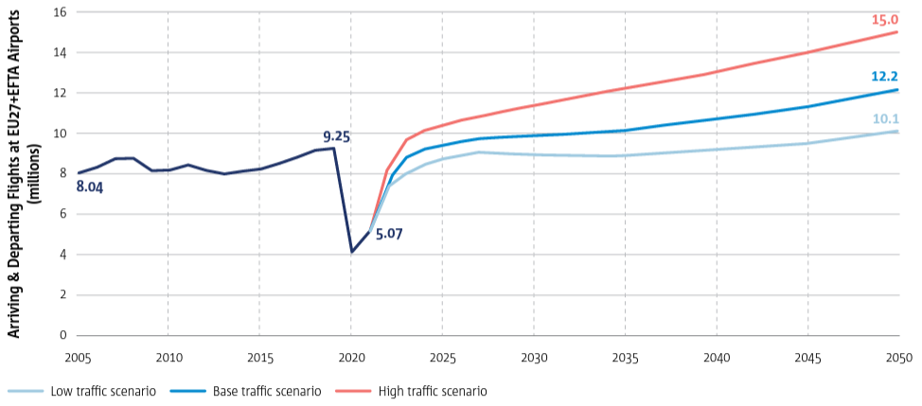
Source: EASA et al., 2022
As seen in Figure A1.2, CO₂ emissions have followed the same trend as air traffic: from 1990 to 2014, CO₂ emissions increased by 80 %, remaining stable between 2005 and 2014; they are, however, also expected to increase by a further 45 % between 2014 and 2035. NO_{x} emissions doubled between 1990 and 2014, but technological developments are expected to increase at a lower rate than in previous years, and a further 43 % increase is expected between 2014 and 2035, considering the air traffic growth forecast.

Figure A1.2 Forecast of traffic growth and CO₂ and NO_{x} emission increases depending on traffic growth (
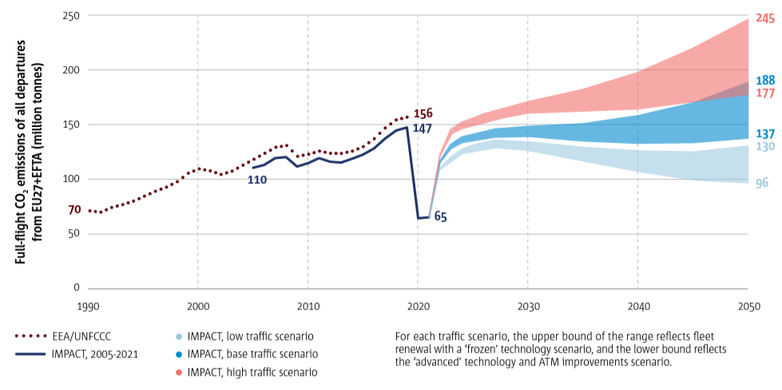
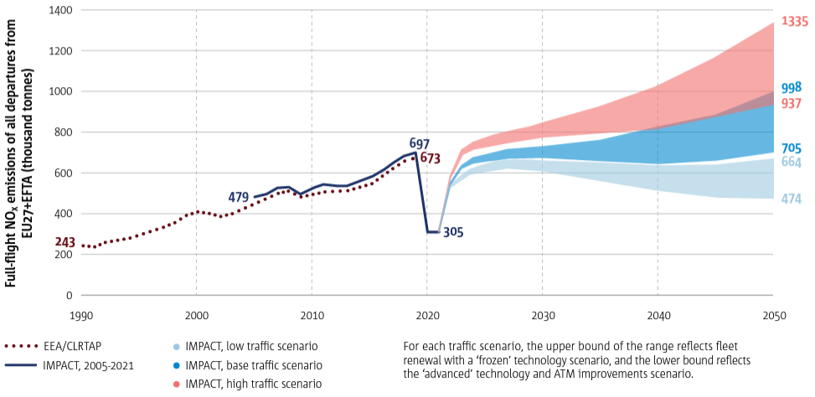
Source: EASA et al., 2022
In 2015, 92 European airports participated in the Airport Carbon Accreditation programme, and 20 of these airports were carbon neutral. Around 80 % of passengers in Europe were handled via an airport with a certified environmental or quality management system. However, by 2035, in the absence of continuing efforts, it is anticipated that some 20 major European airports will face significant congestion and related environmental impacts because of air traffic growth.
Aircraft and their engines must meet international standards for noise and pollutant emissions. Pollutant emissions from engines have been significantly reduced by technological developments. This has been promoted by more stringent NO_{x} limits which have been introduced to avoid potential trade-offs due to the demand for more fuel-efficient engines. The average NO_{x} margin to the ICAO CAEP/6 limit for in-production engine types has increased by about 15 % over the last five years. Additional standards for CO₂ and PM are currently being developed and are expected to enter into force in the near future.
Table A1.1 summarises the different aviation emission species and their change between 2005 and 2014. It also includes the change forecasted up to 2035.
Figure A1.1 Summary of full-flight emission indicators (% change to 2005)
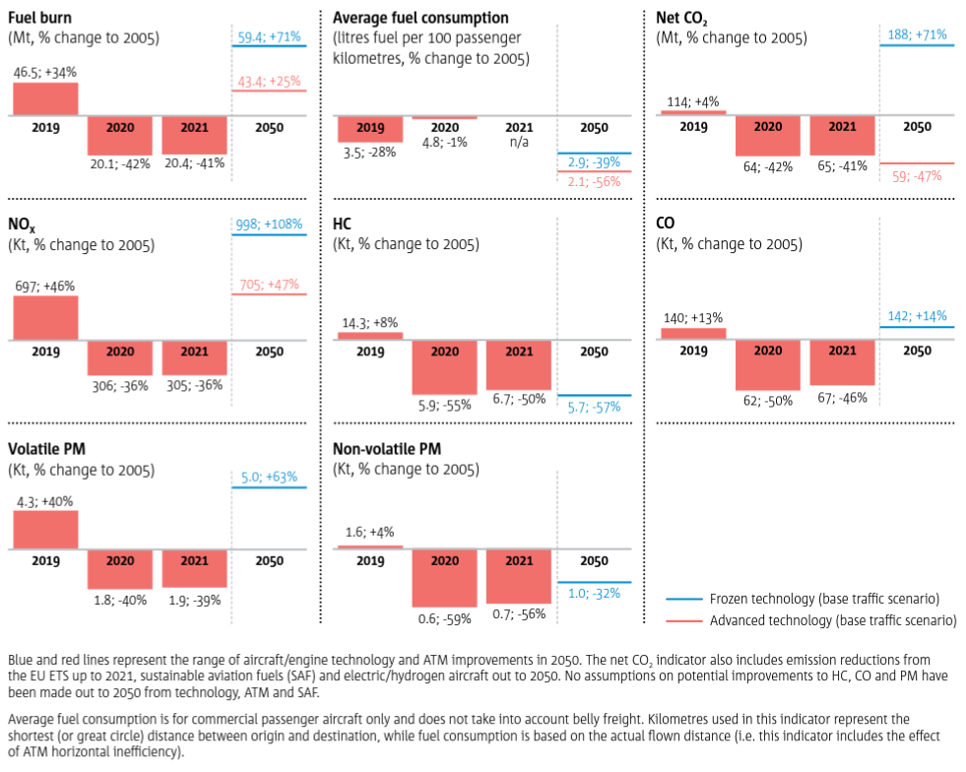
Source: EASA et al., 2022.
Slower growth results in a more slowly ageing fleet. Newer aircraft and engines are more environmentally efficient, so the age of the European aircraft fleet is an important indicator. The mean aircraft age (weighted by the number of flights made by each aircraft) has crept up from 9.6 to 10.3 years, with only 2009 and 2010 seeing reductions (Figure A1.2). These reductions were driven by the rapid expansion of the low-cost fleet, which is younger than average, and retirements of less fuel efficient older aircraft by the traditional scheduled operators in response to higher fuel prices and falling demand (retirements jumped to over 6 % of the fleet per year in 2008 and 2009). In more recent years, the fleet began to age again as a result of slower low-cost carrier growth, and very limited fleet renewal by the traditional scheduled carriers. In 2014, about half of all flights were by aircraft built in 2005 or later. This figure increases to three-quarters if only low-cost carriers are considered. The mean age of the non-scheduled charter fleet has increased most rapidly, reflecting the decline of this segment and the switch to scheduled operations. The rapid expansion of business aviation up to 2008 was accompanied by the introduction of new aircraft, but business aviation declined sharply with the economic downturn, with the focus subsequently shifting to increased utilisation rather than buying new aircraft. The mean age of aircraft used for all-cargo operations (i.e. not including the passenger flights which often carry cargo too) is around 19 years during the whole of this period because of the generally lower daily aircraft utilisation.
Figure A1.3 Mean aircraft age has crept up to above 11 years (Source: EASA et al., 2022)
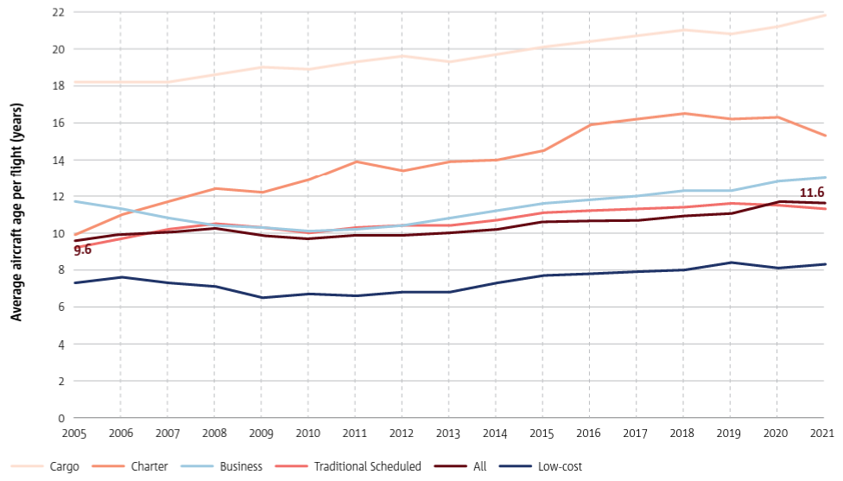

Table A1.2 below reflects the projection of fleet age distribution for 2010 and 2020.
Table A1. 2 World fleet age profile in 2010 and 2020
Age (years) | % in 2010 | % in 2020
0–5 | 27.6 | 32.5
6–10 | 20.5 | 22.9
11–15 | 19.7 | 17.8
16–20 | 23.5 | 16.2
21–25 | 8.6 | 10.6
Note: The growth of the fleet between 2010 and 2020 is expected to be 26 %.
The commercial uptake of sustainable alternative fuels in the aviation sector is very slow, but it is assumed that it will play an important role in reducing aviation greenhouse gas emissions in the coming decades. The European Advanced Biofuels Flightpath provides a roadmap for achieving an annual production rate of 2 million tonnes of sustainably produced biofuel for civil aviation by 2020. European commercial flights have trialled sustainable alternative fuels. However, regular production of sustainable aviation alternative fuels is projected to be very limited in the next few years, and thus it is unlikely that the roadmap’s 2020 target will be achieved.
The reader is advised to refer to EASA et al., (2016) and associated website from which the final report can be downloaded. The underlying data in the figures can also be downloaded as Excel spreadsheets.
            - Additional comments on emission factors
ICAO (2023) (Aircraft Engine Emissions Databank) provides basic aircraft engine emissions data for certificated turbojet and turbofan engines covering the rate of fuel used and the emission factors for HC, CO and NO_{x} at the different thrust settings used. Other relevant emissions data are derived from other sources. The exhaust emissions databank is now accessible via the internet (ICAO, 2023). In addition to HC, CO and NO_{x}, this version also contains emission factors for smoke at the different thrust settings (columns BL to BO of the databank). PM emission factors can be derived from those for smoke, and the methodology used for this conversion (the so-called First Order Approximation version 3 (FOA3)) is published in ICAO, 2007.
The heavy metal emissions are, in principle, determined from the metal content of kerosene or gasoline. Thus, general emission factors for the stationary combustion of kerosene and the combustion of gasoline in cars may be applied. The only exception is lead. Lead is added to aviation gasoline to increase the octane number. The lead content is higher than in leaded car gasoline, and the maximum permitted levels in the UK are shown below. A value of 0.6 g of lead per litre of gasoline should be used as the default value if there is an absence of more accurate information. Actual data may be obtained from oil companies.
Table A2.1 Lead content of aviation gasoline in the UK
AVGAS designation | Maximum lead content (as tetra ethyl lead)
AVGAS 80 | 0.14 g/l
AVGAS low lead 100 | 0.56 g/l
AVGAS 100 | 0.85 g/l
There is little information on PM from aircraft. In Petzold et al. (1999) and Döpelheuer et al. (1998), data are published for various aircraft types. Petzold (1999) also describes the particle size. For newer aircraft, the size distribution is dominated by particles with a diameter between 0.025 and 0.15 μm. For newer aircraft (certified after 1976), such as A300, B737 and DC10, the emission factor is about 0.01 g/kg fuel. Döpelheuer and Lecht (1998) also provide data for different phases of the flight for A300. The factor is higher at take-off (0.05 g/kg) and lower at cruise (0.0067 g/kg), while the factor for climb and descent is about 0.01 g/kg. From combustion science principles, it is anticipated that the PM_{2.5} to PM₁₀ ratio for aircraft engines will be similar to, or higher than, that for internal combustion engines. Given that the ratio for internal combustion engines is estimated to be 94 %, it is reasonable to assume that for aircraft their PM emissions can be considered as PM_{2.5}. The PM_{2.5} to PM₁₀ ratio most commonly used when reporting values within EMEP is 1.0. This is the relationship assumed in this Guidebook.
Little information is currently available about possible exhaust emissions of persistent organic pollutants (POPs) from aircraft engines. Emissions of H₂O may be derived from the fuel consumption at the rate of 1.237 kg H₂O/kg fuel. Using the emission factors, special emphasis should be put on the assumptions of the weight per cent of sulphur (assumed to be 0.05 %). If the percentage of sulphur in the fuel used is different, this should be taken into account. If the sulphur per cent used is, for example, 0.01 % instead of 0.05 %, the emission factor should be divided by five to show the true factor.
            - Black carbon (BC) fractions of particulate matter emissions from aviation
In order to maintain consistency throughout the guidebook, it should be noted that the literature emission factor values used here directly represent elemental carbon (EC), and that these values are assumed to be equal to BC.
Table A3.1 presents an overview of the five studies that have been regarded as relevant sources for BC fractions of PM emissions (f-BC) from aviation. Apart from f-BC, for each study the engine type and emission test modes are listed, as well as the PM emission sampling conditions, as far as information is available. Some of the following references also report figures for organic carbon (OC) which can be input for the further assessment of OC fractions of PM (f-OC).
Petzold et al. (2009) carried out test rig measurements of the emissions from four engine operational conditions in the Sample (study on sampling and measurement of aircraft particulate emissions) Project. The measurements of PM were adjusted to include the particulate emissions in the form of water-bound sulphate. BC and EC values were also measured. Petzold et al. (2009) found that BC equals EC. No trend in emissions could be observed for variations in engine test modes.
Petzold et al. (2003) simulated, in a test rig for cruise power settings, the emissions influence from fuel with low, medium and high sulphur content used by old and new engine technologies. BC and TC (total carbon) emissions are measured. Subsequently, the TC emissions are adjusted by 30 % in an upwards direction (compared with Petzold et al. (2009)) in order to calculate the total mass of PM and determine the f-BC fraction. No trend in emissions could be observed for variations in engine test modes.
Rogers et al. (2005) carried out ground-based plume measurements of the emissions from a jet engine military fighter and a turboshaft engine being used by military helicopters. Rogers et al. (2005) measured EC, OC and total PM mass emissions, and referred to the measured EC factor as the ‘black factor’. Based on one test run, they derived BC factors which could be related to the PM mass emission factors.
Kinsey et al. (2010) reported ground-based plume emissions measurements for nine commercial aircraft engines in three field campaigns of the Aircraft Particles Emissions eXperiment (APEX) 1–3 study. In the supplementary material provided by Kinsey et al. (2010), EC emissions were interpreted as BC and, furthermore, it was noted that volatile PM emissions consist of sulphur and organic PM. In Kinsey et al. (2010), for five aircraft engines, the total PM mass emissions were split into volatile (PM_{vol}) and non-volatile (PM_{non-vol}) fractions. For the present note, the non-volatile share of total PM is assumed to be equivalent to the f-BC fraction.
Agrawal et al. (2008) measured the emissions of, for example, PM, EC and OC from four commercial aircraft. No trends in emissions could be observed for variations in engine test modes. For the present discussion, EC values were used for BC, in accordance with the assumptions made by, for example, Rogers et al. (2005) and Kinsey et al. (2010).
Winther et al. (2012) calculated the emissions of PM for aircraft engines in Copenhagen Airport, based on actual flight operational data and aircraft–engine combinations. The FOA3 method (ICAO, 2008b) was used to estimate the PM emissions, split into volatile PM coming from the sulphur in the fuel and exhaust VOC, and non-volatile PM from soot. Subsequently, a fuel-weighted f-BC fraction (non-volatile share of total PM) was derived taking into account the landing, take off and taxi engine power modes. The f-BC fraction for Copenhagen Airport was similar to the f-BC fraction calculated for LTO for Schiphol Airport in Amsterdam also using the FOA3 method (Andreas Petzold, DLR, 2012, personal communication).
The f-BC and f-OC (if available) fractions derived from the abovementioned studies are listed in Table A3.1.
Table A3.1 BC and OC fractions (%) of PM emissions from relevant studies
Study | Aircraft/Engine types | Test conditions | f-BC | f-OC (ª)
Petzold et al. (2003) | Old engine | Cruise, low sulphur | 61
 |  | Cruise, medium sulphur | 44
 |  | Cruise, high sulphur | 50
 | New engine | Cruise, low sulphur | 75
 |  | Cruise, medium sulphur | 31
 |  | Cruise, high sulphur | 40
Agrawal et al. (2008) | CFM56-7B22 | Mode 1 (4 and 7 %) | 31 | 91.2
 |  | Mode 2 (30 and 40 %) | 8 | 14
 |  | Mode 3 (65 %) | 59 | 16
 |  | Mode 4 (85 %) | 59 | 24
 | CFM56-3B1 | Mode 1 (4 and 7 %) | 48 | 67
 |  | Mode 2 (30 and 40 %) | 60 | 60
 |  | Mode 3 (65 %) | 26 | 44
 |  | Mode 4 (85 %) | 85 | 12
 | CFM56-3B2 | Mode 1 (4 and 7 %) | 55 | 79
 |  | Mode 2 (30 and 40 %) | 69 | 33
 |  | Mode 3 (65 %) | 74 | 19
 |  | Mode 4 (85 %) | 79 | 19
 | CFM56-7B22 | Mode 1 (4 and 7 %) | 47 | 189
 |  | Mode 2 (30 and 40 %) | 72 | 127
 |  | Mode 3 (65 %) | 86 | 15
 |  | Mode 4 (85 %) | 68 | 35
Rogers et al. (2005) | Military F404-GE-400, T700-GE-401 | 65 %–80 %, 67 %–98 % | 56 | 19
Kinsey et al. (2010) | CFM56-2C1 | Various power modes | 38 | 62
 | CFM56-3B1 | Various power modes | 21 | 79
 | AE3007A1E | Various power modes | 38 | 62
 | P&W4158 | Various power modes | 46 | 54
 | RB211-535E4B | Various power modes | 59 | 41
Petzold et al. (2009) | Test rig | Condition1 | 66
 |  | Condition2 | 33
 |  | Condition3 | 54
 |  | Condition4 | 36
Winther et al. (2012) | Copenhagen Airport fleet/engine | Landing | 33
 |  | Take off | 54
 |  | Taxi | 30
Petzold et al. (2003) |  | Average | 50
Agrawal et al. (2008) |  | Average | 58
Rogers et al. (2005) |  | Average | 56
Kinsey et al. (2010) |  | Average | 40
Petzold et al. (2009) |  | Average | 47
Winther et al. (2012) |  | Average | 39
Average (all) |  | Average | 48
(ª) If f-OC values are > 100, the literature indicates that this could be because the sampling methods produce a positive artefact. In this case, the OC positive artefact was assumed to offset the hydrogen and oxygen content of the organic mass, based on previous research (Shah et al., 2004a and 2004b; Agrawal et al., 2008).

Conclusion
The data available are regarded as being too scarce to propose different f-BC fractions for different tiers and explicitly for LTO and CCD in the guidebook’s chapter on aviation. Hence, the same average f-BC fraction (f-BC = 0.48) will be proposed for the simple LTO and CCD methodology in Tier 1, the aircraft type-specific Tier 2 methodology, the Tier 3 methodology based on aircraft type city-pairs and for military aircraft. For piston-engined aircraft, data from Winther and Nielsen (2011) will be used (f-BC = 0.15) based on information from Kupiainen and Klimont (2004).
Table A3.2 lists the tables in the guidebook chapter on aviation which contain f-BC fraction information. These fractions must then be combined with the existing PM factors in GB in order to establish the final BC emission factor in each case.
Table A3.2 Tables in this chapter of the guidebook which contain f-BC fraction data
Table No | Tier | Detail | f-BC source
3.3 | 1 | Old/average fleet; LTO and CCD emission factor. | Present note; f-BC = 0.48
3.5 | 2 | LTO emf. per aircraft type | Present note; f-BC = 0.48
3.4 | 1 | Piston-engined aircraft | Winther et al. (2011); f-BC = 0.48
3.15 | 2 | Military | Present note; f-BC = 0.48

Acknowledgements
Andreas Petzold, DLR, is thanked for technical discussions.
            - EUROCONTROL fuel burn and emissions inventory system
EUROCONTROL has developed the Fuel Burn and Emissions Inventory System (FEIS) to estimates the total masses of jet fuel (for aircraft powered by turbojet, turbofan or turboprop engines) and aviation gasoline (for aircraft powered by piston engines) burnt by all the aircraft that, during the year before, made relevant flights that departed from, or arrived at, or both, an airport (or aerodrome) that is located in a relevant part of the territory of one of the ECAC Member States. The total masses of certain gaseous species and types of PM that were emitted because of the burning of this jet fuel and aviation gasoline are also estimated. This work is done in support of the EEA member countries, including those Member states of the EU, and of ECAC states that are not EEA member countries.
The purpose of this annex is to provide a high-level description of both the procedure by which these estimates are produced and the tools that are used to do the calculations.
The FEIS only uses flight movement information that is available within the EUROCONTROL zone of coverage and only considers IFR flights (no VFR flights), excluding military or special operations. Trajectories of flight movements partly or completely outside of the EUROCONTROL zone of coverage, are completed or generated from flight movements identified in commercial aircraft schedule databases.
The FEIS relies mainly on EUROCONTROL AEM’s ability to process large amount of flight movements efficiently.
AEM is used as outlined below:
- AEM processes flight movements to estimate the amount of fuel burnt, and then estimates the emissions that result from the combustion of this fuel in the engines. A flight movement is the movement on the ground and in the air of an aircraft (an airframe plus its engine(s)) following a 4D path (or profile).
- Above 3 000 ft, this profile is described in terms of a sequence of straight-line segments that are retrieved from the updated flight plan data managed by the EUROCONTROL Network Manager Operations Centre or partly or completely generated for flight movements outside of the EUROCONTROL zone of coverage. The fuel burn is calculated for each segment of a flight profile thanks to the aircraft performance information provided by EUROCONTROL’s BADA (EUROCONTROL, 2016b). This database provides altitude- and attitude-dependent performance and fuel burn data for more than 200 aircraft types. Once the amount of fuel burnt is calculated for each segment, the Boeing Fuel Flow Method 2 (BFFM2) is used to correct the amount of fuel that is burnt before multiplying by the EFs.
- Below 3 000 ft, because information about flight profiles is not sufficiently accurate, AEM calculates the amount of fuel burnt according to the ICAO LTO cycle methodology, which was defined by the ICAO Engine Certification specifications, and models flight movements (below 3 000 ft) as a series of defined thrust levels for defined lengths of time associated with each LTO cycle flight phase. The fuel burn is calculated thanks to the ICAO Aircraft Engine Emissions DataBank (AEED), which provides EIs and fuel flow for a very large number of aircraft engines. As EUROCONTROL has developed a table that lists a large range of aircraft models and the engines with which they are generally equipped, AEM can link each flight movement processed by AEM to a specific engine as identified by its Unique Identification Number (UID), as listed in the ICAO Engine Exhaust Emissions Databank. A ‘standard’ LTO cycle lasts for a total of 32 minutes and 54 seconds, of which the engines are in idle mode for 26 minutes while taxiing out before taking off and taxiing in after landing (19 minutes and 7 minutes, respectively). But for many airports in Europe, the time spent with the engine thrust set to idle is different from the 26 minutes of the ICAO LTO cycle. Therefore, to improve the accuracy of the system, EUROCONTROL replaces default ICAO taxi-in and taxi-out times with actual average annual airport taxi-in and taxi-out times, as calculated by EUROCONTROL. Once the amount of fuel burnt in a phase of the LTO cycle is known, the associated emissions can be calculated.
Table A4.2 AEM fuel burnt and corresponding emissions calculation method
Height (feet) | Fuel burnt | NO_{x}, UHCs and CO | CO₂, H₂O and SO_{x} | VOCs
> 3 000  CCD | BADA | BFFM2 | Proportional to the mass of fuel burnt | Proportional to the mass of UHCs generated
≤ 3 000 | AEED and other databases
As such, the FEIS implements a methodology that lies somewhere between a Tier 3A and a Tier 3B fuel and emissions inventory methodology.
The FEIS generates report for
the UNFCCC and
the LRTAP Convention of the United Nations Economic Commission for Europe.
The FEIS is updated on an annually with the previous year’s flight movement data (and the associated fuel and emissions estimations), and historical data since 2005 are maintained. if methodology changes result in a change of more than 0.5 % from the previous year’s estimated emissions, the data are recalculated.
A more detailed description of the EUROCONTROL FEIS is available on request from the EEA.

            - Emission calculator accompanying files
The accompanying emission calculator files are available as an electronic annex alongside the main Guidebook files at http://www.eea.europa.eu/publications/emep-eea-guidebook-2016.
Users will find two files:
- Master emission calculator (Annex 1): Which allows to estimate the fuel consumption and the corresponding emissions for a large number of aircraft types for different stage lengths but with an LTO cycle based on ICAO and European average time.
- LTO emission calculator (Annex 2): Which allows to estimate fuel and emissions for LTO cycles based on average annual taxi times for a wide range of individual European airports.

Disclaimer: The fuel burn and emission data provided in this spreadsheet are intended to assist the European Union (EU) and its Member States in maintaining and providing homogeneous emissions inventories. The data are not absolute values, but rather estimations. These estimates should not be used for comparing fuel efficiency and emission data between aircraft models and manufacturers. The engine type associated with each aircraft is the most commonly used type for that aircraft in 2022. A detailed description of the method used to produce these estimates, can be found in the "EUROCONTROL Method for Estimating Aviation Fuel Burnt and Emissions in the Framework of the EMEP/EEA Air Pollutant Emission Inventory Guidebook 2023", available from EUROCONTROL. @EUROCONTROL 2023.

() ‘LTO cycles’ refer to landing and take-off cycles. The International Civil Aviation Organization (ICAO) defines an LTO cycle as those activities occurring up to 3 000 ft (914.4 m) above ground level — see ICAO (2011).
() Available at http://www.ceip.at
() Flights flying under civil Instrument Flight Rules (IFR).
() It is good practice to clearly state the reasoning and justification if any country opts to use the GPG2000 definitions.
() Where nm = nautical miles, 1 nm = 1 852 km.
() http://www.icao.int/environmental-protection/Pages/modelling-and-databases.aspx

